**Capstone Project Title**

Thesis submitted in partial fulfillment of the

requirements for the

**Post Graduate Certificate Program in**

**Data Science and Machine Learning**

By

|  |
| --- |
| **SUSOVAN DAS** |
| MITHUN R |
| SIVAKUMAR S |
| HIMANSHI SHARMA |
| ANUSHA G |
| BHASWATI BANERJEE |
| SREYASHI BASAK |

Under the guidance of

[Akshatha]



**Acknowledgment**

We would like to express our sincere gratitude to all those who have contributed to the successful completion of this project.

First and foremost, we extend our heartfelt thanks to Akshatha Ma’am, our project supervisor, for her invaluable guidance, support, and encouragement throughout this research. Her insights and expertise have been instrumental in shaping the direction and outcome of this project.

We are deeply grateful to the team at Manipal Institute of Technology and UNext team for providing the opportunity to undertake this project. Their cooperation has been crucial for the completion of this study. We would also like to acknowledge the support and resources provided by my institution Manipal Institute of Technology and UNext Team. The access to academic resources and the conducive research environment has greatly facilitated my work.

Our heartfelt appreciation goes to our team colleagues and friends, whose constant support and feedback have been invaluable. Their constructive criticism and encouragement have motivated me to strive for excellence.

A special mention goes to our families for their unwavering support and understanding during the course of this project. Their patience and encouragement have been a source of strength for us.

Finally, we would like to thank all those who have directly or indirectly contributed to this project. Your support has been greatly appreciated.

Thank you all for your immense support and encouragement.

Sincerely,

Student Names

|  |
| --- |
| **SUSOVAN DAS** |
| MITHUN R |
| SIVAKUMAR S |
| HIMANSHI SHARMA |
| ANUSHA G |
| BHASWATI BANERJEE |
| SREYASHI BASAK |

**Abstract**

The increasing rate of hotel reservation cancellations poses significant challenges for the hospitality industry, impacting revenue and operational efficiency. This data science project aims to address these issues by developing a machine learning model to predict hotel booking cancellations based on historical data and various features. The primary objectives are twofold: first, to accurately forecast cancellations, and second, to identify key factors influencing these cancellations. The project leverages statistical analysis and visualization tools, such as Power BI, Tableau, Jupyter Notebook, Matplotlib, and Seaborn, to derive actionable insights for hotel management. The literature review highlights the impact of dynamic pricing and strategic customer behaviour on cancellation rates. Our analysis indicates that online reviews and booking flexibility significantly affect hotel reservation dynamics. The project's scope includes feature analysis, operational insights, and ensuring model scalability and robustness. By employing evaluation metrics like Accuracy, Precision, Recall, and F1-Score, the model's performance is rigorously assessed. The findings provide a deeper understanding of booking behaviours and help optimize strategies to mitigate cancellations, ultimately enhancing customer satisfaction and improving hotel revenue management.

**Table of Contents**

1. Acknowledgment ………………………………………………………………….………….Page 2

2. Abstract ………………………………………………………………………………………...Page 3

3. Introduction …………………………………………………………………………………….Page 7

- Overview of Project Importance and Objectives

- Problem Statement

4. Motivation……………………………………………………………………………………….Page 7

5. Project Scope ………………………………………………………………………………….Page 7

- Prediction Model Development

- Feature Analysis

- Operational Insights

- Scalability

- Evaluation Metrics

6. Project Goal…………………………………………………………………………………….Page 8

7. Literature/Market Survey………………………...……………………………………………Page 8

- Overview of Hotel Industry Challenges

- Impact of Dynamic Pricing and Strategic Customer Behaviour

- Importance of Online Reviews and Booking Flexibility

8. Organisation of the Report……………………………………………………………………Page 9

- Introduction

- Motivation

- Project Scope

- Literature/Market Survey

- Project Description

- Business/Domain Understanding

- Project Stakeholders

- Datasets Understanding

- Data Limitations

- Benefits of Project

9. Exploratory Data Analysis…………………………………………………………………...Page 10

- Data Collection

- Data Exploration

- Data Cleaning

- Data Transformation

10. Visualisations………………………………………………………………………………..Page 10

1. Figure 1: Hotel Booking Cancelled Rate Illustration
2. Figure 2: Count of Cancellations by Reserve Status
3. Figure 3: Distribution of Hotel Arrivals (2015-2017)
4. Figure 4: Count of Arrivals for Resort and City Hotels (2015-2017)
5. Figure 5: Hotel Type Distribution
6. Figure 6: Meal Plan Preferences
7. Figure 7: Deposit Type Distribution
8. Figure 8: Distribution Channel Usage
9. Figure 9: Repeat Guest Status
10. Figure 10: Monthly Cancellation Trends
11. Figure 11: Customer Type Distribution
12. Distribution of Hotel Type with respect to Cancellation Rate
13. Distribution of Repeated and Not Repeated Guests with respect to Cancellation Rate
14. Distribution of Meals with respect to Cancellation Rate
15. Distribution of Market Segment with respect to Cancellation Rate
16. Distribution of Distribution Channel with respect to Cancellation Rate
17. Distribution of Customer Type with respect to Cancellation Rate
18. Distribution of Assigned Room Type with respect to Cancellation Rate
19. Distribution of Deposit Type with respect to Cancellation Rate
20. Deposit Type Influence on Cancellations
21. Hotel Type Influence on Cancellations
22. Monthly Cancellation Distribution
23. Cancellation Distribution by Lead Time
24. Cancellation Distribution by Market Segment
25. Cancellation Distribution by Distribution Channel
26. Cancellation Distribution by Customer Type
27. Cancellation Distribution by Assigned Room Type
28. Cancellation Distribution by Meal Plan
29. Cancellation Distribution by Reserved Room Type
30. Cancellation Distribution by Deposit Type
31. Monthly Booking Distribution
32. Booking Distribution by Lead Time
33. Booking Distribution by Market Segment
34. Booking Distribution by Distribution Channel
35. Booking Distribution by Customer Type
36. Booking Distribution by Assigned Room Type
37. Booking Distribution by Meal Plan
38. Booking Distribution by Reserved Room Type
39. Booking Distribution by Deposit Type
40. Lead Time Analysis for Bookings
41. ADR Distribution
42. Stays in Week Nights
43. Stays in Weekend Nights
44. Distribution of ADR by Cancellation Status
45. Distribution of Stays by Cancellation Status
46. Booking Changes Impact on Cancellations
47. Special Requests Impact on Cancellations
48. Total of Special Requests
49. Reservation Status Distribution
50. Comparison of Cancelled and Non-Cancelled Bookings
51. Comparison of Lead Time for Cancelled and Non-Cancelled Bookings

11. Model Development…………………………………………..…………………………….Page 44

- Logistic Regression

- Interpreting the Odds for Each Variable

- Plotting the Confusion Matrix

- Identifying the Best Cut-off Value

- ROC Curve

- Youden's Index

- Decision Tree/ Random Forests/ Gradient Boosting Machines

- Decision Tree for Classification

- Random Forest for Classification

- XGBoost for Classification

- Hotel Booking Cancellation Prediction (ANN)

- Creating ANN Architecture

- Input Layers

- Model Compilation

- Training the Data

- Summarizing History for Accuracy

- Summarizing History for Loss

- Plotting the Confusion Matrix

- Classification Report

- ROC Curve

- Score Card

- Youden Index

12. Key Results……………………………………………………………………………….Page 48

13. Conclusion……………………………………….………………………………………..Page 58

14. References……………………………………………..…………………………………Page 58

**Introduction**

Cancellation prediction analytics are vital in the hospitality sector for both hotels and customers to accurately assess the likelihood of booking cancellations. This Data Science project has two primary objectives: First, to predict hotel booking cancellations based on historical data and various features; Second, to identify the most influential factors in determining these cancellations. Insights from this analysis can significantly benefit hotels by providing a deeper understanding of booking behaviours and key determinants of cancellations. In recent years, both the City Hotel and Resort Hotel have experienced a significant increase in their reservation cancellation rates. This surge in cancellations has led to a range of challenges, including reduced revenue and underutilized hotel rooms. Reservations in advance allow hotels to prepare for guests by arranging rooms and adjusting their preparations to meet guest needs. However, last-minute cancellations result in the underutilization of hotel resources, adversely impacting hotel efficiency.

**Problem Statement**

This project aims to build a predictive model to determine whether a hotel booking will be cancelled. This prediction is crucial for hotels as cancellations affect revenue and operational planning. The dataset contains numerous features related to booking, such as lead time, deposit type, and special requests, adding to the model's complexity. The data preprocessing steps involve feature selection and engineering, handling missing values, and addressing noise in the data. Different models will be trained, evaluated using appropriate metrics, and interpreted by analyzing the most important features in the context of hotel booking cancellations.

**Motivation**

With the growing trend of dynamic pricing and flexible booking policies, understanding the drivers behind cancellations has become crucial. Effective prediction and mitigation strategies can help hotels manage resources better, improve occupancy rates, and enhance customer satisfaction.

**Project scope**

1. Prediction Model Development: Develop a machine learning model to accurately predict the likelihood of hotel booking cancellations based on historical data.

2. Feature Analysis: Identify and analyse the key features that significantly impact the likelihood of booking cancellations.

3. Operational Insights: Provide actionable insights for hotel management on optimizing booking strategies and reducing cancellations.

4. Scalability: Ensure the model can handle large datasets and be applicable across different types of hotels and market conditions.

5. Evaluation Metrics: Utilize metrics such as Accuracy, Precision, Recall, and F1-Score to evaluate model performance.

**Project Goal**

The hospitality industry faces significant challenges with booking cancellations, which can disrupt operations and impact revenue. Developing effective prediction strategies is crucial for hotels to optimize occupancy rates and improve customer satisfaction.

**Literature/Market survey**

As technology advances and customer preferences change, the hotel sector of today finds itself at the intersection of innovation and tradition, constantly changing to fit the dynamic terrain. Analysing hotel reservation data becomes an essential tool for comprehending patterns, forecasting customer behaviour, and streamlining operational strategies within this complex framework (Koh and Hassim, 2021). Online guests often have the choice to reserve a hotel stay with no cancellation fees or with free cancellation at a discounted rate. Because dynamic hotel pricing is becoming more and more popular, the free cancellation policy—which was once thought of as an insurance against the unpredictability of future changes in travel plans—has recently been linked to strategic customer behaviour (Masiero et al, 2020). Customers are using the internet to benefit from comparable price and ease of booking. Before making a travel-related purchase, 95% of consumers conduct online research. The best offers are a major factor in driving customers to websites (Octane research). Hotel patrons utilize a wide array of information sources, including search engines, comparison websites, supplier websites, and online travel agencies (OTAs) (Murphy et al. 2015). Ye et al. (2011) demonstrate that online travel reviews have a substantial effect on online sales, with online bookings increasing by more than 5% for every 10% increase in traveller review ratings. Whereas, cancellations of reservations have a big influence on demand-management choices in the hotel sector. (Antonio et al , 2017). Undoubtedly, there are reasonable explanations for some of these reservation cancellations, such as rescheduled vacations, business meetings, illness, inclement weather, and other circumstances. However, Chen and Xie (2013) and Chen, Schwartz, and Vargas (2011) have noted that a significant portion of these cancellations currently are caused by customers who are fixated on finding the greatest discounts. Keeping track of cancellations, at least broken down by market groups or booking types, is crucial for revenue management as it helps spot trends and improve projections, as well as overbooking and cancellation policies (Ivanov, 2014; Mehrotra & Ruttley, 2006).

**Organisation of the report**

The report is organized as follows: The Introduction provides an overview of the project's importance and objectives. The Motivation section explains the reasons behind the study. The Project Scope outlines the key tasks and goals. The Literature/Market Survey reviews relevant research and market trends. Finally, the report concludes with the Project Description, Business/Domain Understanding, Project Stakeholders, Datasets Understanding, Data Limitations, and Benefits of the Project.

**Project Description**

**Business/Domain Understanding**

Understanding the business context is crucial for effective application of data analytics in the hotel industry. It involves recognizing the operational challenges and customer behaviours that impact hotel bookings and cancellations.

**Project stakeholders**

Stakeholders include MIT-DSML PGCP 6 students and mentor. Effective communication and collaboration among these groups has been considered essential and crucial for successful project completion, implementation and utilization of insights.

**Datasets understanding**

Test models on the testing set. Calculate performance metrics (e.g., Accuracy, Precision, Recall, F1- Score). Perform cross-validation.- Power BI or Tableau for Data Visualization - Jupyter Notebook for Analysis and ML Model deployment - Matplotlib and Seaborn for Visualization in Jupyter - Statistical Analysis using Python.

**Data Limitations**

The dataset may have limitations, such as missing values, incomplete records, and potential biases. Addressing these issues is crucial for developing accurate and reliable predictive models.

**Benefits of project**

The project aims to provide hotels with actionable insights to reduce cancellations, optimize occupancy rates, and enhance customer satisfaction. Implementing predictive models can lead to more efficient resource management and improved revenue stability.

**Exploratory Data Analysis**

**Data collection**

The dataset consists of 119,390 entries with 36 features, including the target variable, "Is Cancelled". The data has been collected from a comprehensive hotel booking dataset.

The dataset for this project is sourced from an online data repository, available on Kaggle.

**REMOVING INSIGNIFICANT VARIABLES**

**Description: Finding out the unique values**

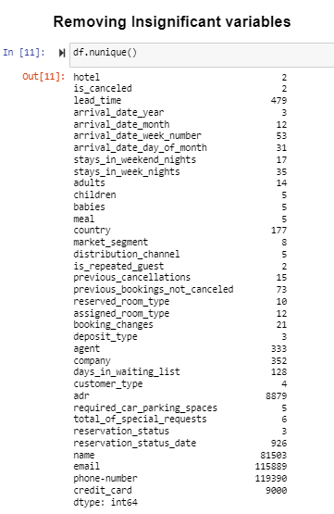

**Description: Dropping unnecessary variables**









**Data Transformation**

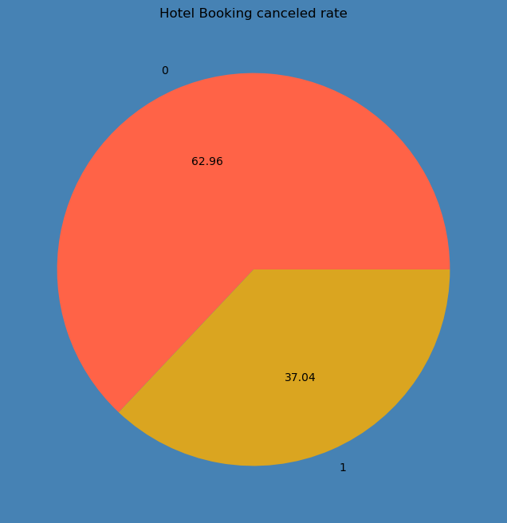

**Figure 1: Hotel Booking Cancelled Rate Illustration**

* Description: Pie chart showing the proportion of cancelled and non-cancelled bookings.
* Insight: 62.96% of bookings are not cancelled, while 37.04% are cancelled, highlighting a significant cancellation rate that impacts hotel operations.

**Majority of Bookings are Not Cancelled:**

62.96% of the bookings are not cancelled (labeled as "0"). This indicates that most customers follow through with their hotel bookings.

**Significant Cancellation Rate:**

37.04% of the bookings are cancelled (labeled as "1"). While less than the non-cancelled rate, this still represents a substantial portion of the total bookings, suggesting that over a third of the bookings do not proceed as planned.

**Operational Implications for the Hotel:**

The high rate of cancellations could have significant implications for hotel operations and revenue management. It suggests the need for strategies to minimize cancellations or effectively manage the impact of such cancellations.

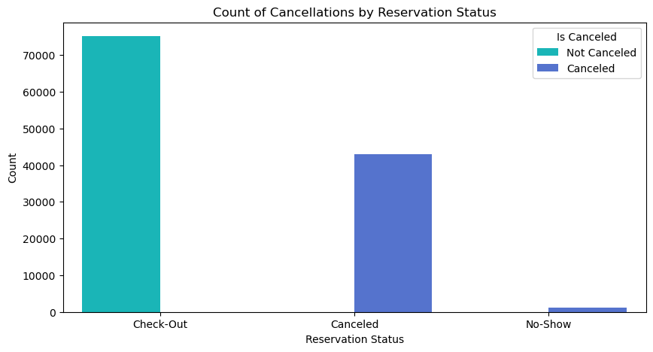

**Figure 2: Count of Cancellations by Reserve Status**

* Description: Bar chart comparing the count of cancelled and non-cancelled bookings, along with No show comparison.
* Insight: The comparatively higher number of cancellations suggests a need for better booking strategies to minimize revenue loss and operational disruptions.

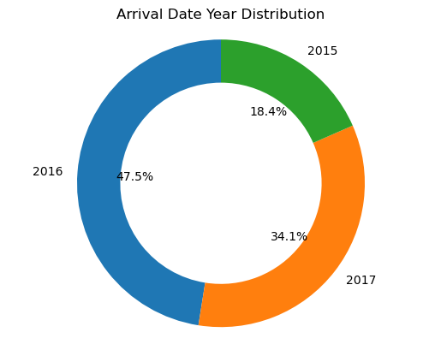

**Figure 3:**

* **Description:** This donut chart illustrates the distribution of hotel arrivals across three years: 2015, 2016, and 2017. It shows that 18.4% of arrivals occurred in 2015, 47.5% in 2016, and 34.1% in 2017.
* **Insight:** The peak arrival year was 2016, indicating potential factors driving higher bookings during that year. The significant drop in 2017 suggests changing trends or external factors affecting hotel arrivals. Analysing these factors could help in strategic planning to boost future bookings.

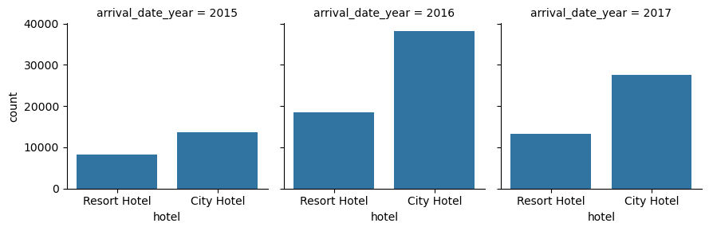

**Figure 4:**

* **Description:** This set of bar charts shows the count of arrivals for resort and city hotels from 2015 to 2017. Each year is represented separately, highlighting the number of arrivals for each hotel type.
* **Insight:** City hotels consistently have higher arrivals compared to resort hotels. The peak in 2016, especially for city hotels, suggests a particularly strong year for urban tourism or business travel. The slight decline in 2017 for both hotel types might indicate a shift in travel patterns or market conditions.

**Univariate Analysis**

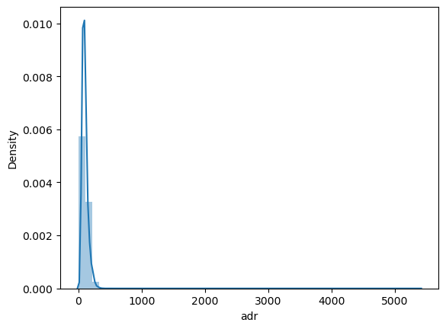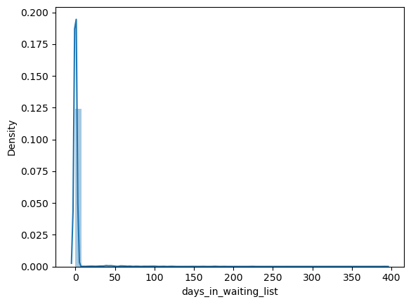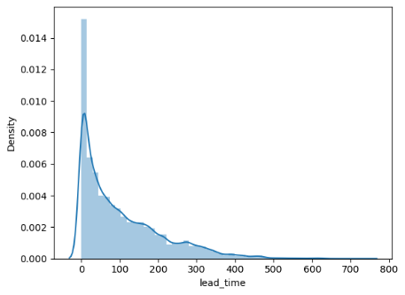

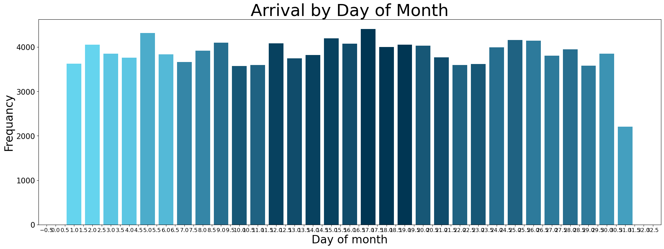

**Insight:** The bar plot shows the arrival of customers is frequent between 8th to 23rd of a month approximately.

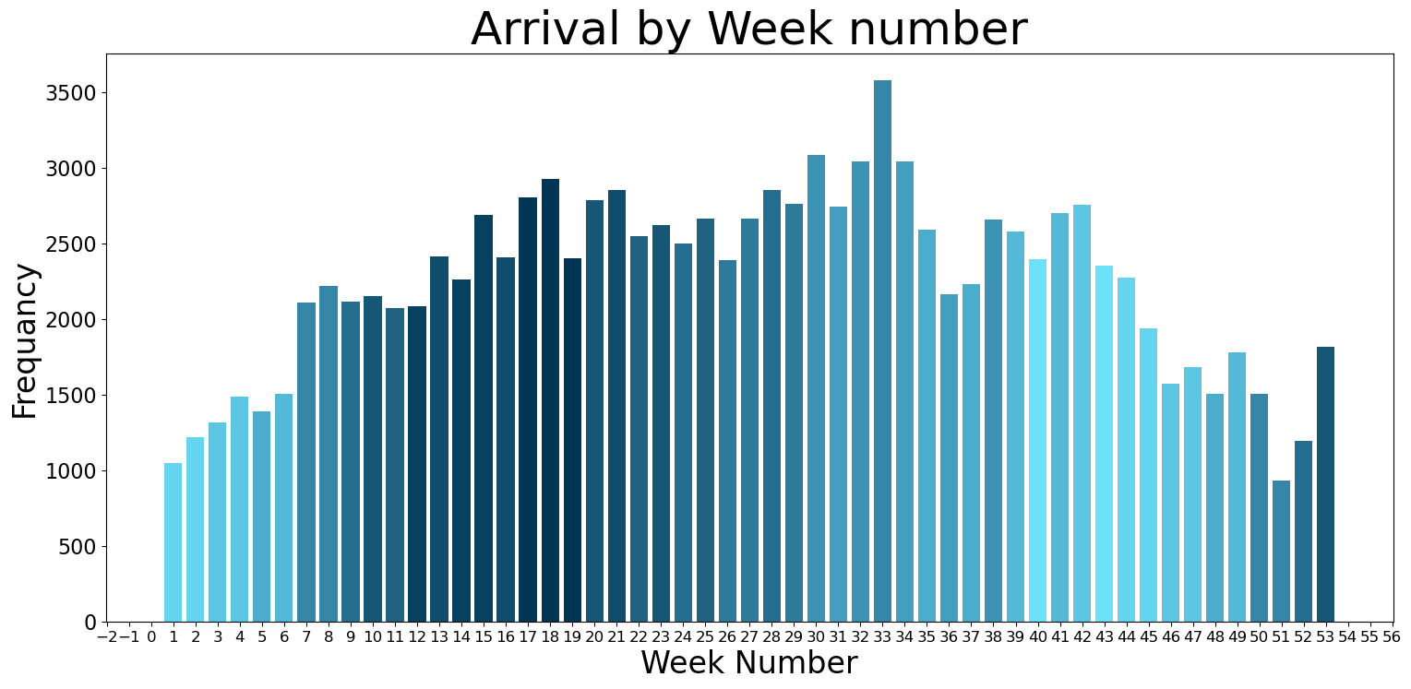

Insight: The bar plot shows the arrival of customers is frequent during weeks 7 to 25 and 50 to 53. This might be due to holiday seasons or vacation times.

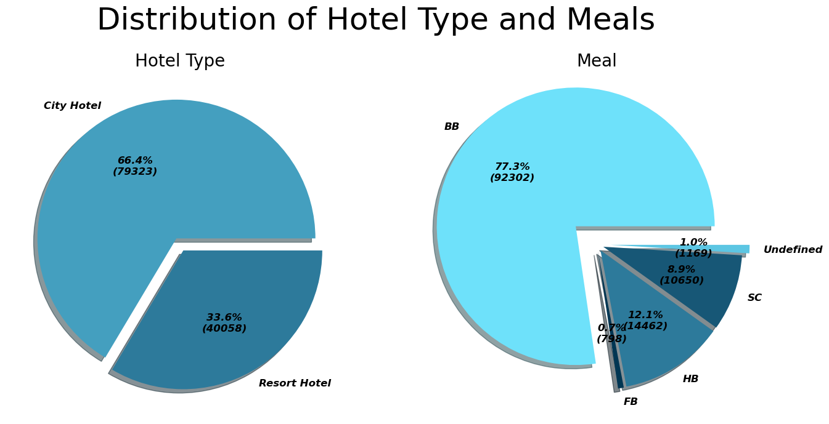

**Figure 5: Hotel Type Distribution**

* **Description:** Pie chart showing the distribution of bookings between city hotels (66.4%) and resort hotels (33.6%).
* **Insight:** City hotels are more popular, likely due to proximity to business and cultural attractions.

**Figure 6: Meal Plan Preferences**

* **Description:** Bar chart displaying the distribution of meal plans among bookings.
* **Insight:** Bed and Breakfast (BB) is the most preferred meal plan (77.3%), indicating guests' preference for simplicity and convenience.

**Insight:**

**Hotel Type:** The majority of bookings (66.4%) are for City Hotels, while Resort Hotels account for 33.6% of the bookings. This suggests that city hotels are more popular for this dataset, likely due to their proximity to business or cultural attractions.

**Meal:** The dominant meal plan is BB (Bed and Breakfast), accounting for 77.3% of the bookings. This indicates that the majority of guests are looking for a basic breakfast included in their stay. Other options like SC (Self Catering), HB (Half Board), FB (Full Board) and Undefined are less popular, likely reflecting customer preference for flexibility or a simple breakfast option.

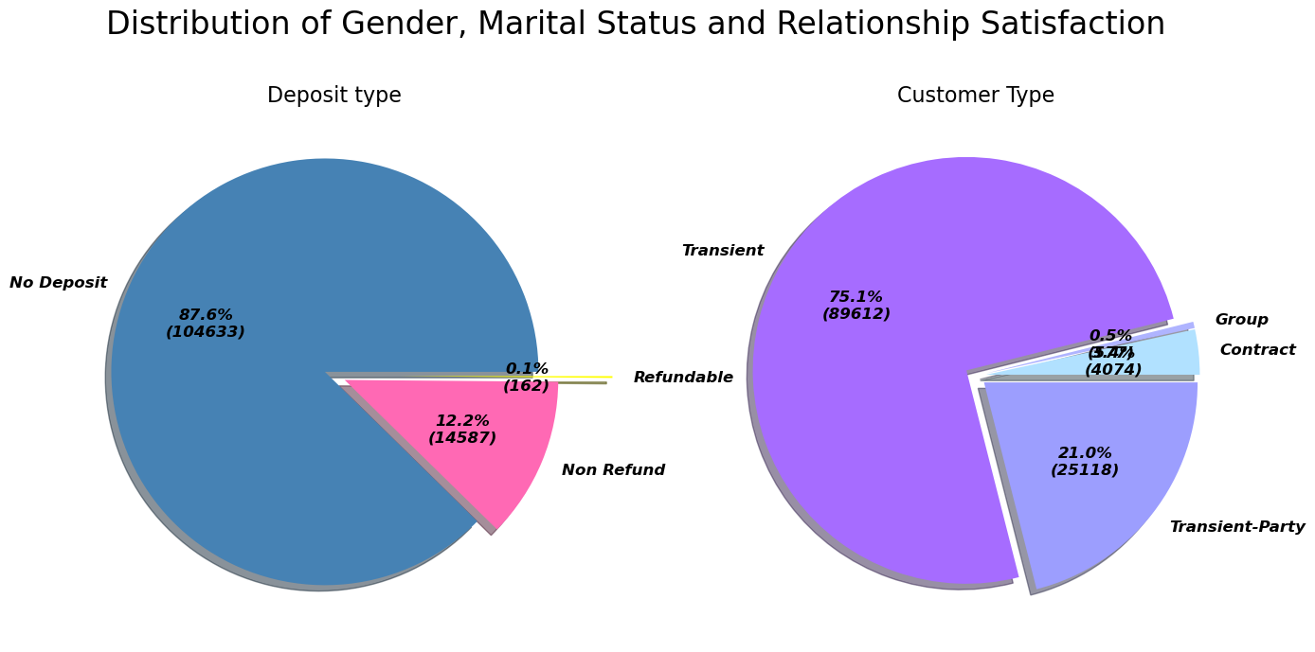

**Figure 7: Deposit Type Distribution**

* + **Description:** Pie chart showing the prevalence of different deposit types.
  + **Insight:** No Deposit is the most common (87.6%), while Non-Refundable deposits (12.2%) suggest some price-sensitive customers are willing to commit.

**Insight:**

Deposit Type

* No Deposit: This is overwhelmingly the most common deposit type, accounting for 87.6% of bookings. This suggests that a majority of customers prefer booking without upfront payment.
* Non-Refund: This type makes up a significant portion (12.2%), indicating that customers are willing to commit to non-refundable rates, potentially for lower prices or greater flexibility.
* Refundable: This is the least prevalent type, making up only 0.1% of bookings. This suggests that customers are generally less interested in refundable options, potentially due to higher prices or less flexibility.

Customer Type

* Transient: This is the dominant customer type, comprising 75.1% of bookings. This indicates that individual travellers are the primary clientele for the business.
* Transient-Party: This type comprises a significant portion (21%) of bookings, suggesting a substantial number of customers are traveling with a group or family.
* Contract and Group: These types are less common, making up 3.47% and 0.5% respectively. This indicates that business contracts and large group bookings are relatively less frequent.

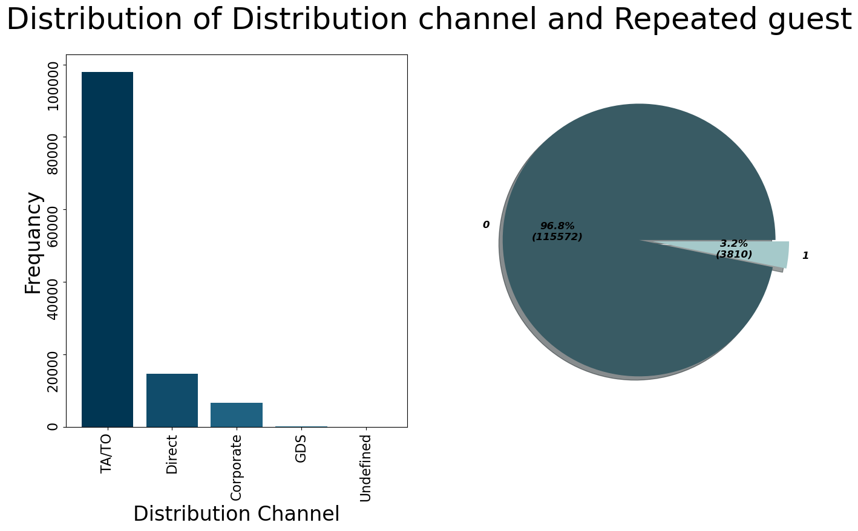

**Figure 8: Distribution Channel Usage**

* + Description: Bar chart showing the distribution of bookings across different channels.
  + Insight: Travel Agents (TA/TO) are the primary source, suggesting reliance on third-party platforms, with potential for increasing direct bookings.

Figure 9: Repeat Guest Status

* + Description: Pie chart indicating the proportion of repeat versus non-repeat guests.
  + Insight: Low repeat guest rate (3.2%) points to a need for improved customer loyalty programs.

**Insight:**

Distribution Channel:

* The bar chart indicates that the majority of bookings are made through Travel Agents (TA/TO). This suggests that hotels are heavily reliant on travel agents for their bookings.
* Direct bookings come in second, indicating that a significant proportion of customers book directly with the hotel.
* Corporate bookings are less frequent, suggesting that business travel makes up a smaller part of the hotel's clientele.
* GDS and undefined channels contribute minimally to overall bookings.

Repeated Guest Status:

* The pie chart indicates that the vast majority of customers (96.8%) are not repeated guests. This suggests that the hotel has a high churn rate.
* Only 3.2% of customers are repeat guests.

Insights:

* High Reliance on Travel Agents: The hotel's high reliance on travel agents might indicate a need to develop direct booking strategies to attract more customers and potentially reduce reliance on third-party platforms.
* Low Repeat Guest Rate: The low repeat guest rate suggests a need for improvement in customer experience and loyalty programs to encourage repeat bookings.
* Focus on Transient Customers: The combination of both plots suggests the hotel might be heavily focused on attracting transient customers who book through travel agents and are less likely to return.

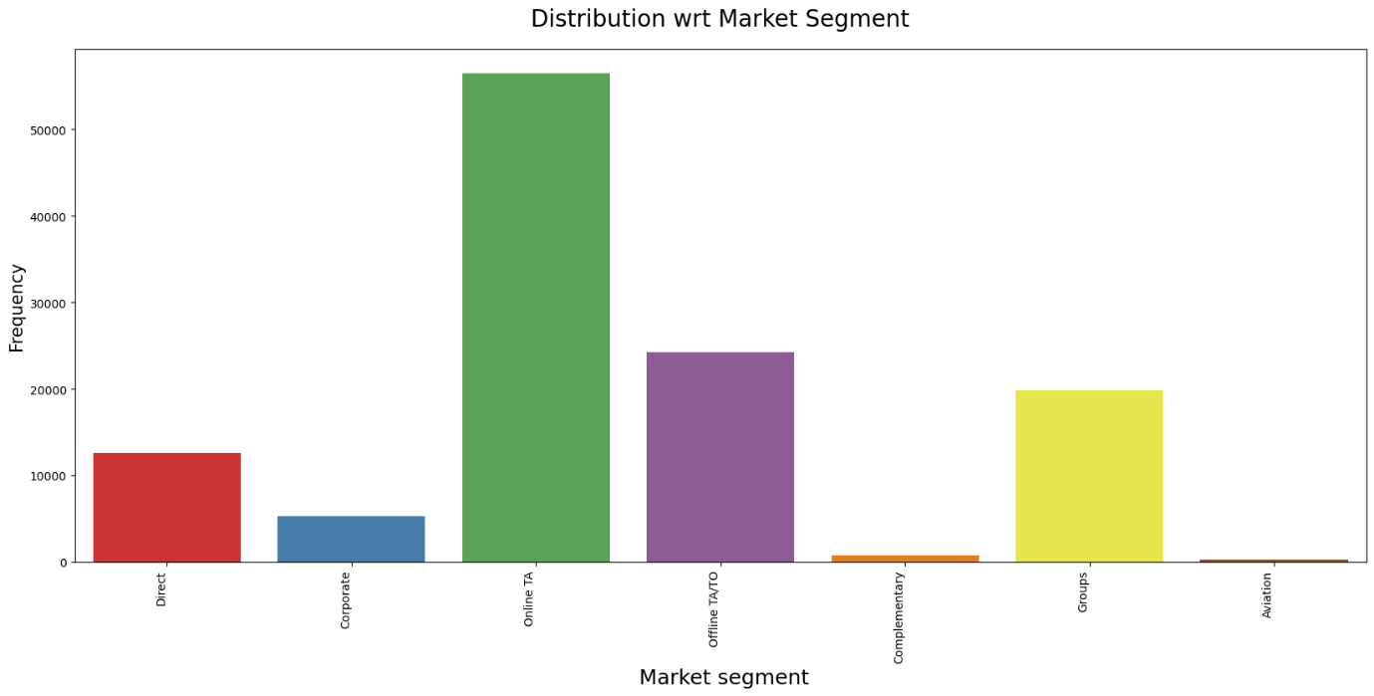

.

**Insight:**

* Online Travel Agencies are Key: The high number of bookings from online travel agencies indicates a strong reliance on these platforms for customer acquisition. This might mean that the hotel has a robust partnership with online travel agencies, possibly offering competitive rates or participating in marketing programs.
* Offline Travel Agencies Still Relevant: The presence of offline travel agencies in the booking process suggests that there is a segment of customers who prefer traditional booking methods. This might require the hotel to maintain good relationships with these agencies and offer suitable packages or incentives.
* Group Bookings: The substantial number of group bookings suggests that the hotel might be well-equipped to handle large groups, potentially offering specific packages or amenities.
* Direct Booking Opportunities: The moderate number of direct bookings presents an opportunity for the hotel to increase its direct channel sales by promoting loyalty programs, offering competitive rates, and improving its online booking experience.
* Potential for Growth in Corporate Segment: The modest number of corporate bookings indicates a potential for growth in this segment. The hotel might consider developing tailored packages or partnerships with corporate clients to attract more business travel bookings.

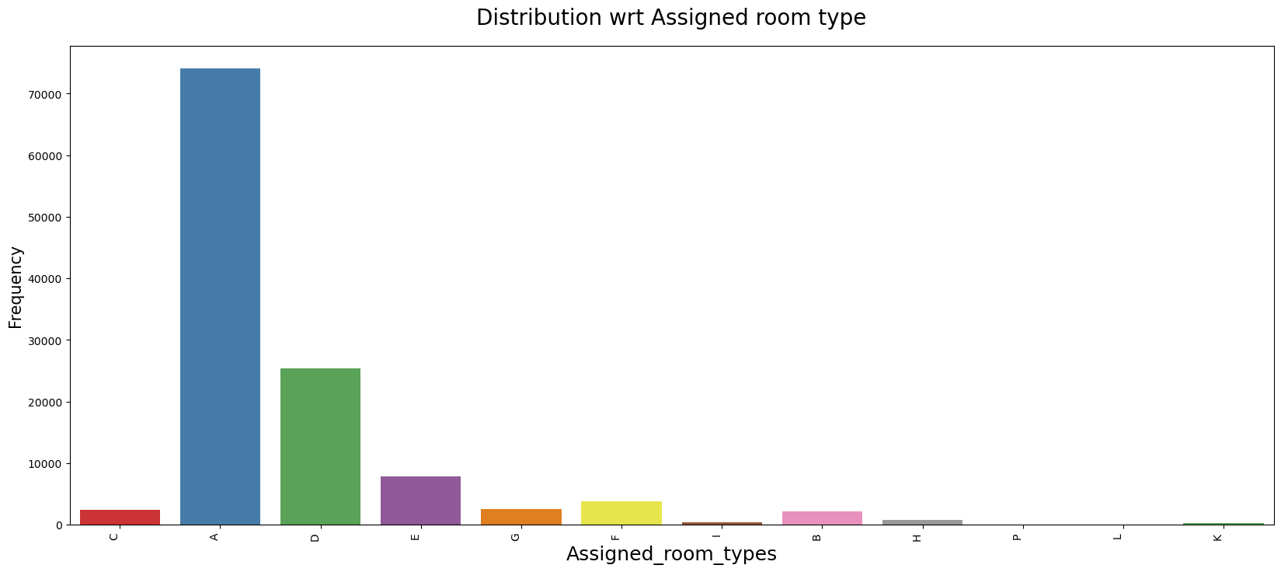

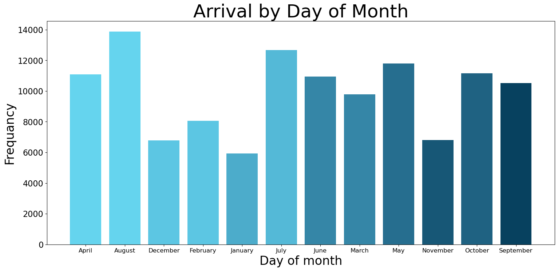

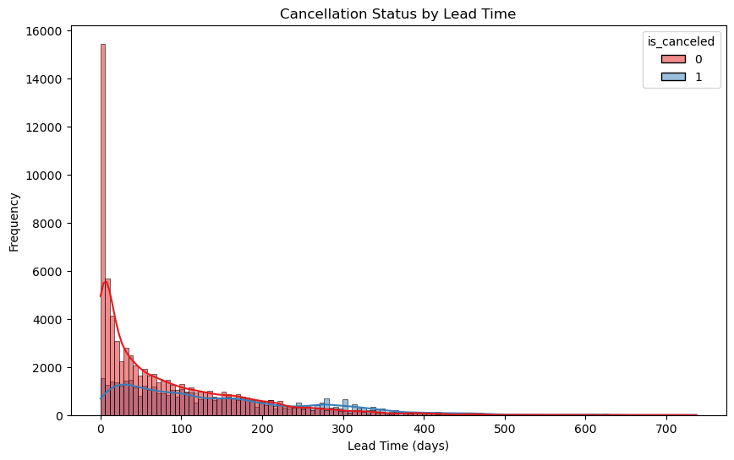

**Insight:**

Insight from the Lead Time Distribution Histogram The histogram shows the distribution of lead times for hotel bookings, separated into cancelled (1) and non-cancelled (0) categories.

Key Observations: Skewed Distribution Towards Short Lead Times:

Both cancelled and non-cancelled bookings predominantly cluster around shorter lead times. The frequency drops significantly as the lead time increases. This indicates that most bookings are made with relatively short notice.

Higher Cancellation Frequency at Short Lead Times: There’s a notable peak at very short lead times (close to 0 days) where both cancellations and non-cancellations are high. This suggests that very last-minute bookings are common and have a mixed outcome in terms of cancellations. The red bars (non-cancelled) are significantly higher at these very short lead times compared to blue bars (cancelled), indicating a lower probability of cancellation for bookings made close to the check-in date.

Decreasing Cancellation Probability with Increasing Lead Time: As the lead time increases beyond approximately 50 days, the proportion of cancelled bookings (blue bars) relative to non-cancelled bookings (red bars) tends to decrease. This suggests that cancellations are less common for bookings made well in advance. However, even with longer lead times, cancellations do occur but are less frequent compared to non-cancellations.

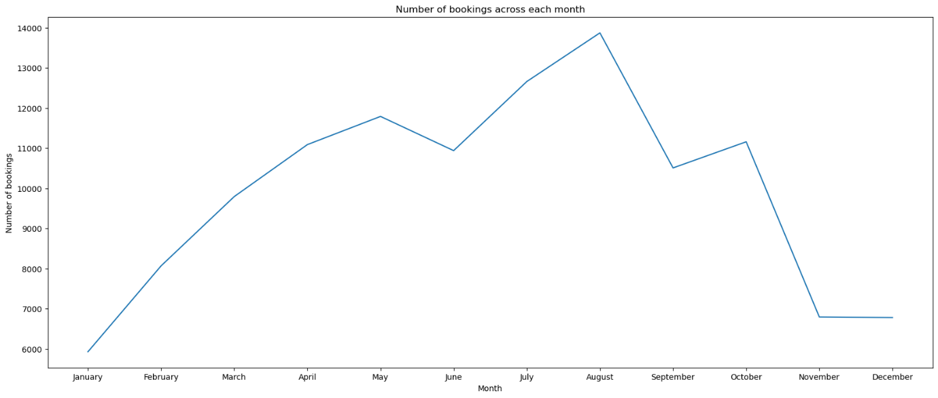

**Figure 10: Monthly Cancellation Trends**

* + **Description:** Line chart displaying cancellation rates across different months.
  + **Insight:** Seasonality affects cancellations, with peaks during off-peak seasons, suggesting targeted strategies for different times of the year.

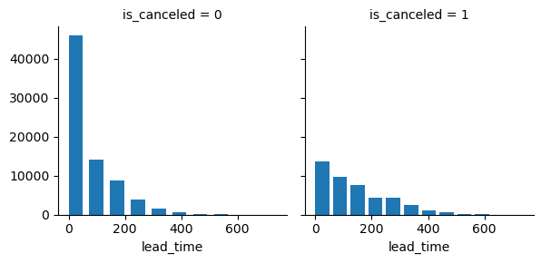

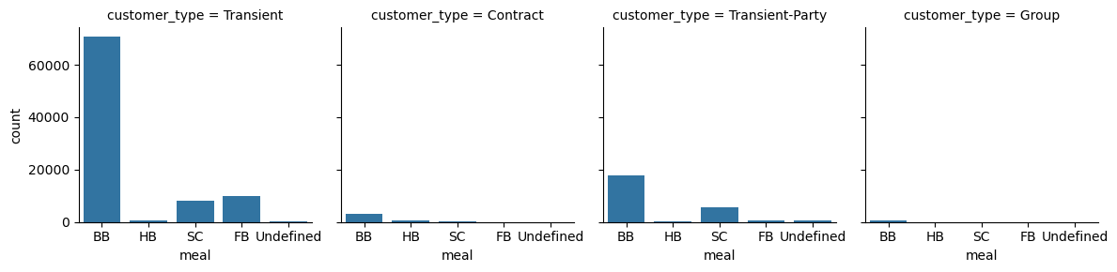

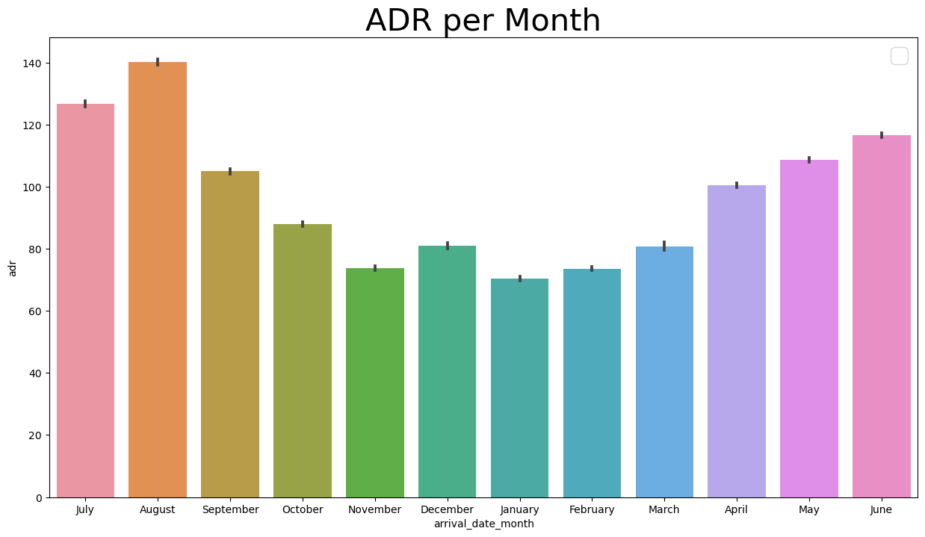

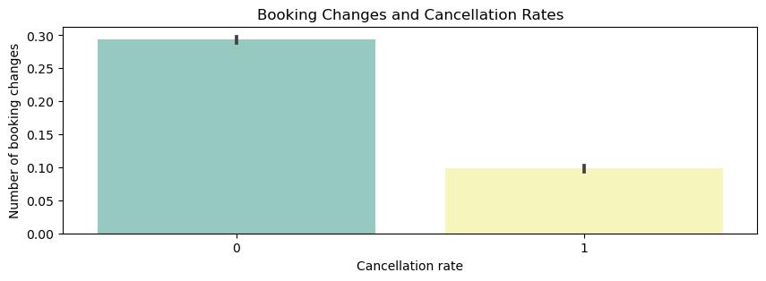

**Insight:**

It shows that bookings with no cancellation (represented by "0" on the x-axis) have a significantly higher number of changes compared to bookings that have been cancelled (represented by "1" on the x-axis). This suggests that a higher number of booking changes is associated with a lower cancellation rate.

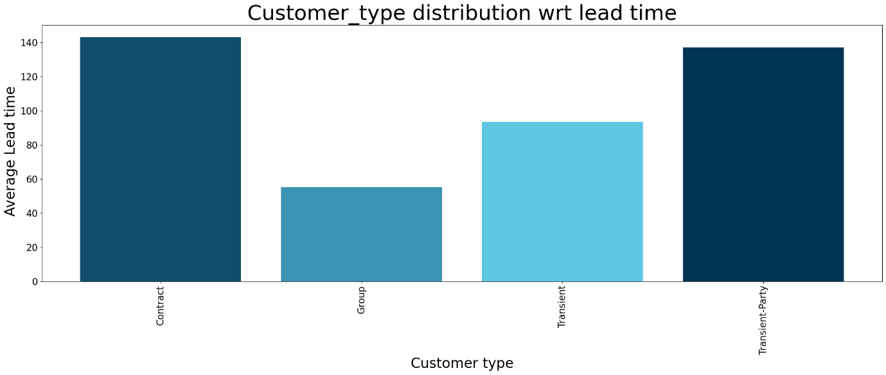

**Figure 11: Customer Type Distribution**

* + **Description:** Pie chart depicting the distribution of customer types.
  + **Insight:** Transient customers dominate (75.1%), with Transient-Party (21%) indicating significant group or family travel.

**Insight:**

* Contract customers have the highest average lead time, suggesting they plan their trips further in advance.
* Transient-Party customers have the second highest average lead time, indicating they also book in advance.
* Transient customers have a moderate lead time, implying they book a bit closer to their travel dates.
* Group customers have the shortest average lead time, indicating they often book on short notice.

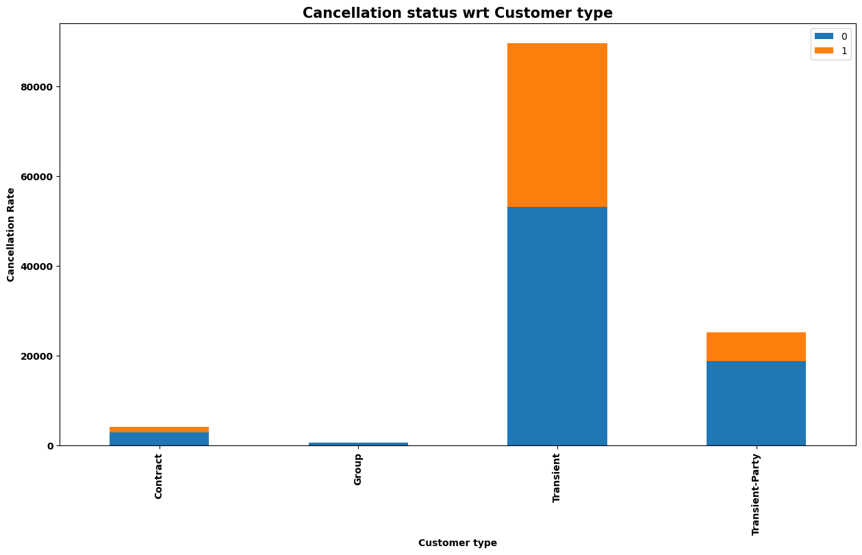

**Insight:**

* Transient customers have the highest number of bookings, and a significant portion of them are cancelled (represented by the orange bar).
* Contract customers have a very low cancellation rate, indicating a high level of commitment.
* Group customers also have a very low cancellation rate.
* Transient-Party customers show a moderate cancellation rate.

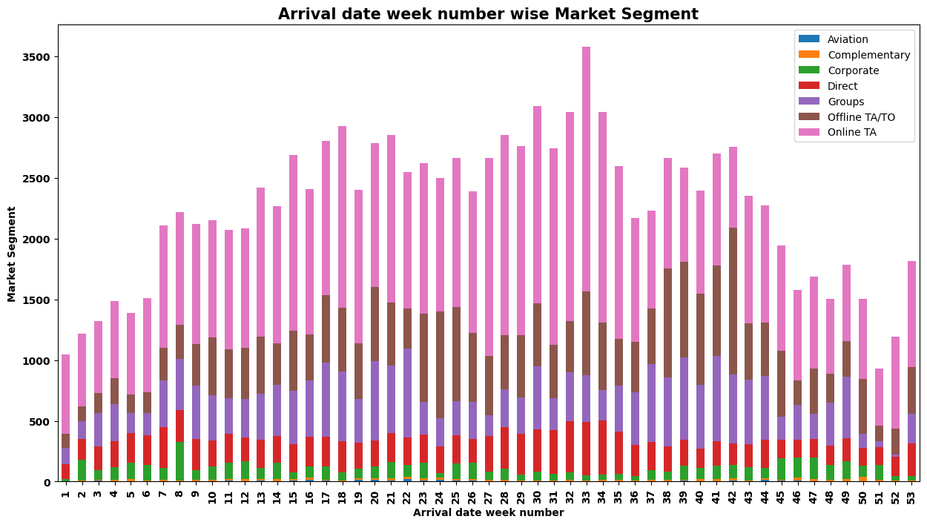

**Insight:**

Dominant Market Segments:

* Online TA (Pink): This segment consistently dominates across all weeks, indicating that online travel agencies are the primary source of bookings throughout the year.
* Offline TA/TO (Brown): This segment also has a significant presence, particularly in weeks where Online TA bookings are lower.

Seasonal Trends: There is a noticeable increase in bookings from week 1 through week 28, with a peak around weeks 25 to 30. Post week 30, there is a gradual decline in bookings towards the end of the year. Weeks 39 to 44 show a secondary peak in bookings, which might correlate with another travel season or holiday period.

Market Segment Variations:

* Corporate (Green): Corporate bookings are relatively low throughout the year but maintain a consistent presence. This indicates a steady demand from business travellers.
* Direct (Red): Direct bookings also show a consistent but low volume across the weeks.
* Groups (Purple): Group bookings vary, with higher volumes in some weeks (e.g., weeks 21 to 24 and weeks 38 to 40), possibly due to events or group travel seasons.
* Complementary (Orange) and Aviation (Blue): These segments are minimal, indicating they are not significant sources of bookings.

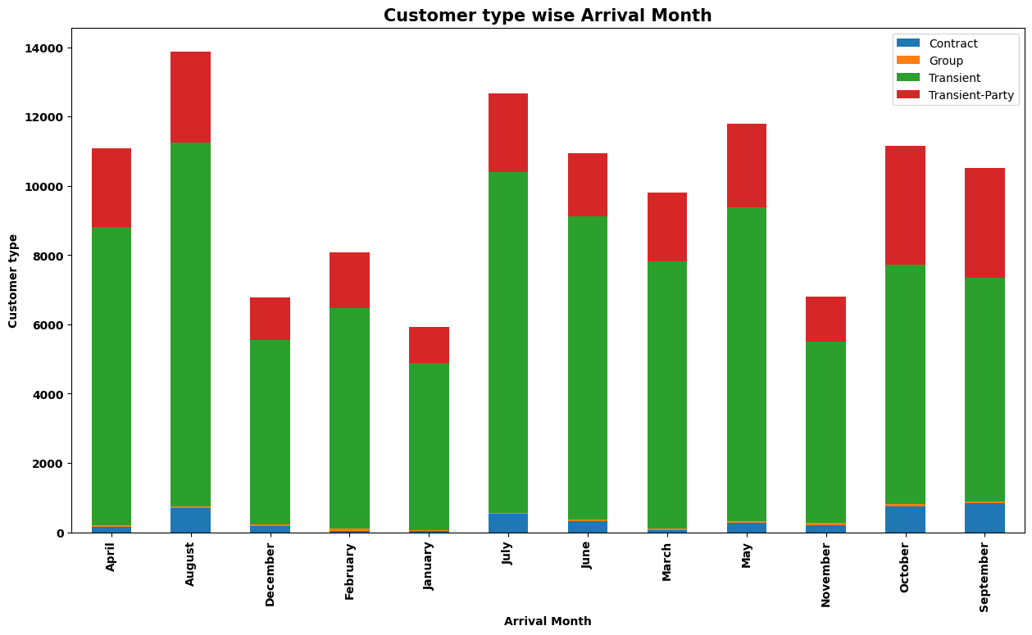

**Insight:**

Customer Type Distribution:

* Transient customers (green) dominate the bookings across all months. This implies that transient customers, who are likely individual travellers, are a significant portion of the bookings and should be given particular attention in the prediction model.
* Transient-Party customers (red) also contribute significantly, especially in April, August, and July. These are likely groups of transient travellers.
* Group (orange) and Contract (blue) customers have minimal contributions in most months, suggesting that these types are less frequent.

Seasonal Trends: Peaks in bookings are observed in April, August, July, and October. These months could be high seasons for the hotel, possibly due to holidays or favorable weather conditions. December and May show lower booking numbers, which might be off-peak seasons.

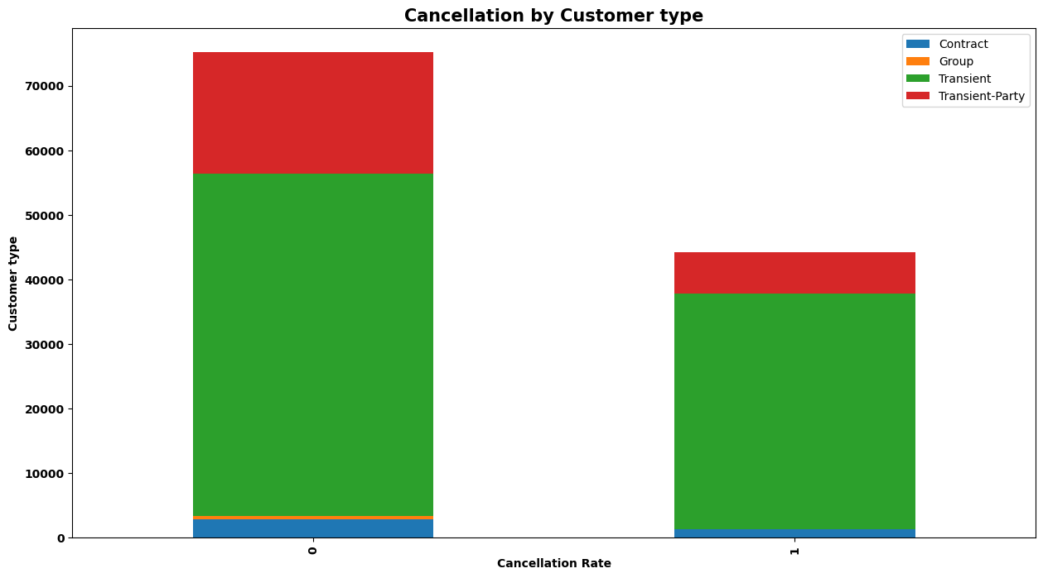

**Insight:**

Customer Types and Cancellations:

Transient Customers (Green): Dominates both the non-cancelled and cancelled bookings. The high volume in both categories indicates that transient customers are a significant portion of the hotel's clientele. Despite their large numbers, transient customers have a considerable rate of cancellations.

Transient-Party Customers (Red): They are the second-largest group in both non-cancelled and cancelled bookings. Their proportion remains relatively stable between the two categories, indicating that transient-party customers have a consistent, though significant, cancellation rate.

Contract Customers (Blue): They represent a very small fraction of both non-cancelled and cancelled bookings. The low volume in cancellations suggests that contract bookings are relatively stable and less likely to be cancelled.

Group Customers (Orange): They have minimal representation in both categories, similar to contract customers. Group bookings show a negligible impact on overall cancellation rates, possibly due to the organized nature of group travel.

Cancellation Trends: High Cancellation Risk: The significant presence of transient and transient-party customers in the cancellation category suggests that these customer types are more prone to cancellations. This is likely due to the nature of their bookings, which are often more flexible.

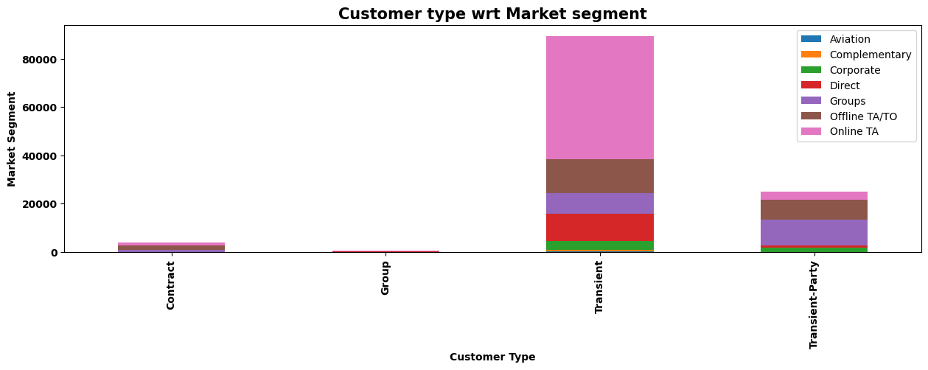

**Insight:**

* Online TA is the dominant channel for both Transient and Transient-Party customers.
* Direct bookings are more common for Contract and Transient-Party customers compared to other types.
* Offline TA/TO plays a significant role in all customer types, especially for Group and Contract customers.

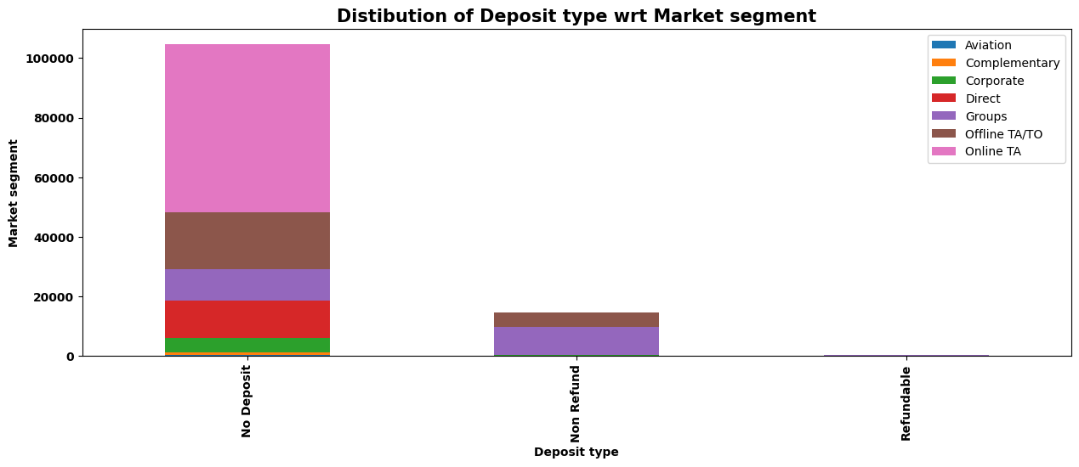

**Insight:**

* No Deposit is the most prevalent deposit type, especially for Online TA bookings.
* Non-Refund is commonly used with Group bookings, possibly indicating price sensitivity.
* Refundable is a less common choice, suggesting it's not a significant factor in booking decisions.

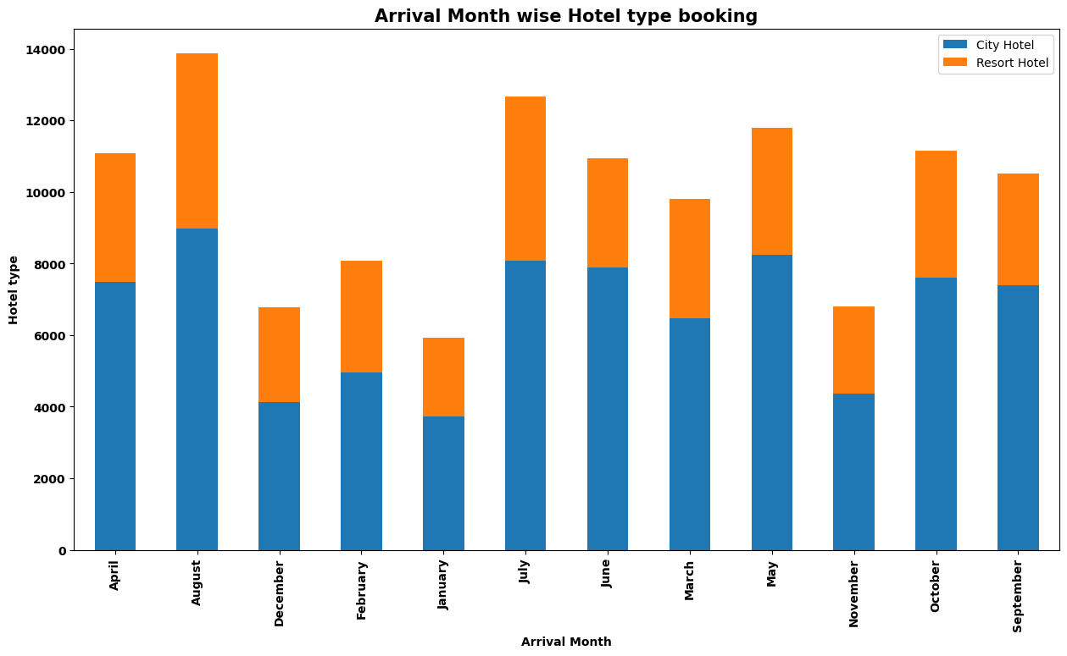

**Insight:**

* August has the highest number of bookings, followed by April and July.
* Bookings for resort hotels are significantly higher in the summer months (July, June, August), while bookings for city hotels are higher in other months like March, April, and May.
* November and December have the lowest number of bookings overall

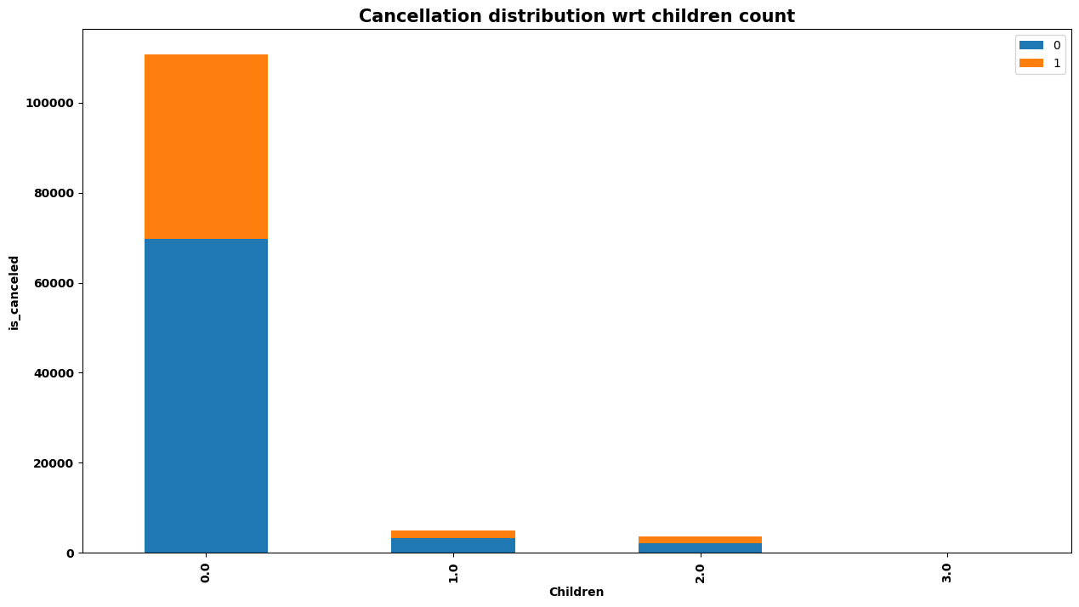

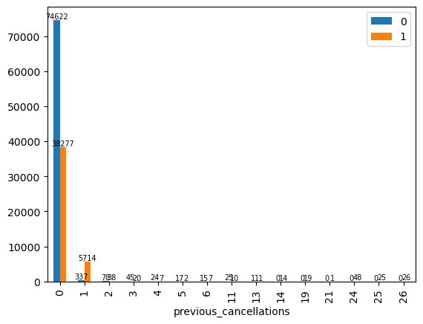

**Previous Cancellations vs. Current Cancellations**

Insight: The bar chart shows that guests with no previous cancellations (0) have the highest frequency of current cancellations, while guests with one or more previous cancellations show a significantly lower frequency. This indicates that guests with a history of cancellations are less likely to cancel again.

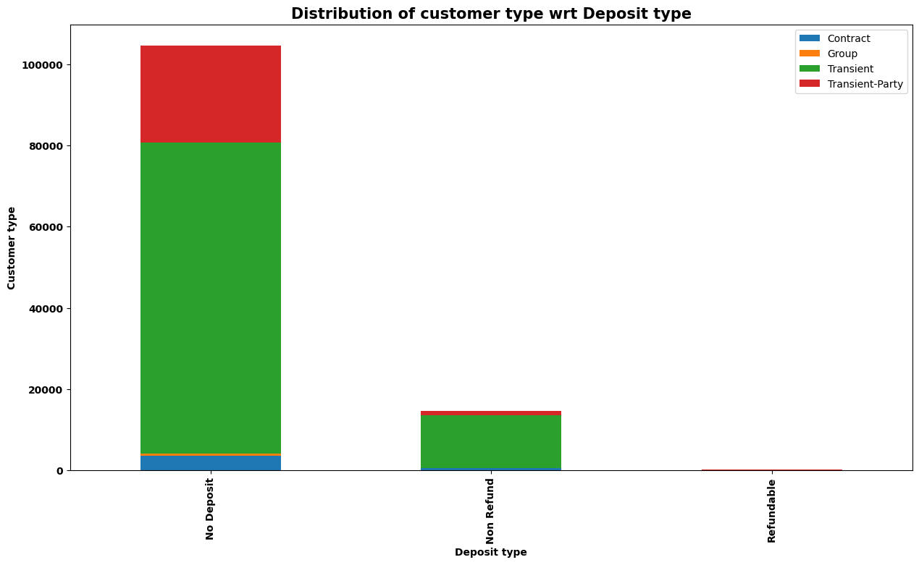

**Distribution of Customer Type wrt Deposit Type**

Insight: The chart shows that the majority of customers do not make a deposit. Transient guests (individual travellers) constitute the largest group without a deposit, followed by group bookings. The smallest segment is those who book with a refundable deposit. This suggests that the lack of deposit could be correlated with higher cancellation rates.

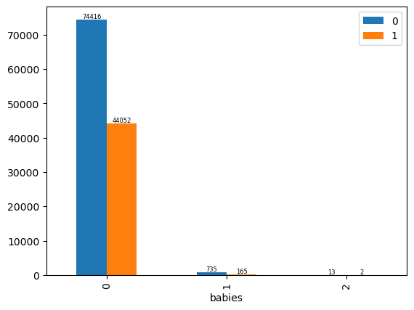

**Babies vs. Cancellation Rate**

**Insight:** The chart indicates that bookings with no babies (0) have a higher cancellation rate compared to those with babies. This suggests that guests traveling with babies are more likely to follow through with their bookings.

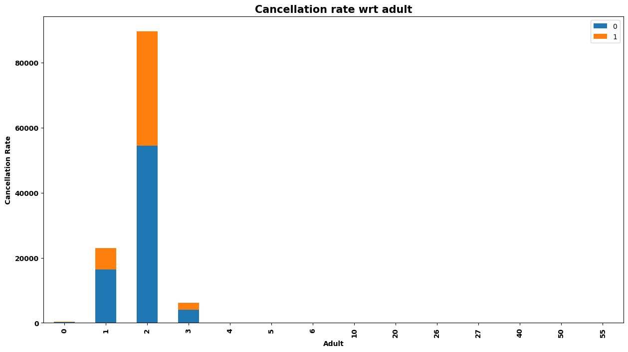

**Cancellation Rate wrt Number of Adults**

**Insight:** The chart shows the distribution of cancellations across different numbers of adults in a booking. Bookings with 2 adults show the highest frequency of cancellations, followed by those with 1 and 3 adults. This may indicate that couples are more likely to cancel their bookings compared to solo travellers or larger groups.

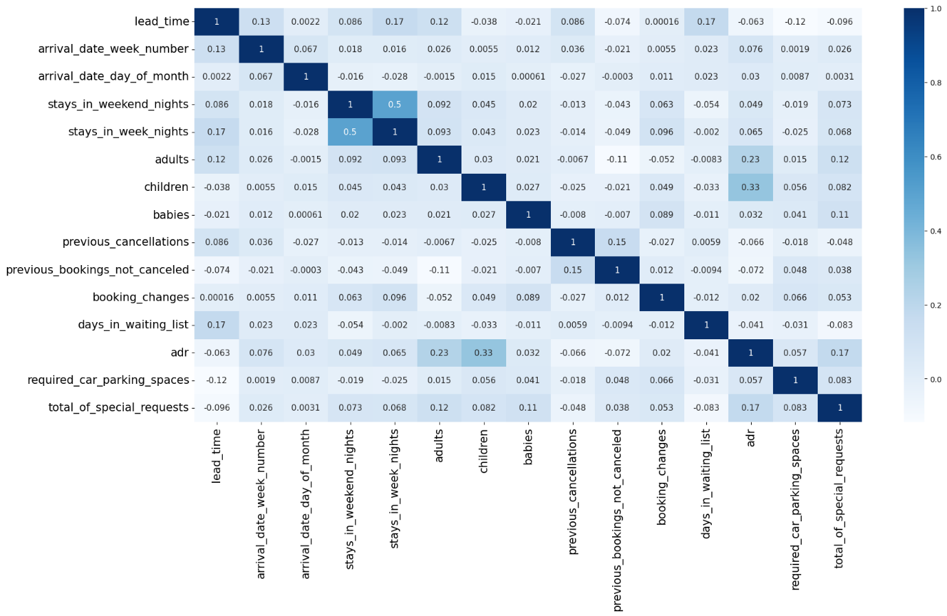

**Correlation Matrix**

Insight: The heatmap presents the correlation between various features related to hotel bookings and cancellations. Key insights include:

* + The highest positive correlation with cancellations is the "previous_cancellations" feature.
  + The "total_of_special_requests" has a negative correlation with cancellations, aligning with the earlier insight that more special requests correlate with lower cancellation rates.
  + "Lead_time" (the number of days between booking and arrival) has a positive correlation with cancellations, suggesting that longer lead times might lead to higher chances of cancellation.

**Overall Insights:**

**1. Guest Commitment:** Guests with previous cancellations are less likely to cancel again, while bookings with no babies and couples show higher cancellation rates.

**2. Booking Practices:** The majority of guests do not make deposits, particularly transient and group guests, potentially leading to higher cancellation rates.

**3. Feature Correlation:** Key features impacting cancellation rates include previous cancellations, special requests, and lead time. Longer lead times are positively correlated with cancellations, while special requests show a negative correlation.

**4. Stay Duration and Rate:** Longer stays, which often come at lower ADRs, exhibit fewer cancellations, indicating stronger commitment from these guests.

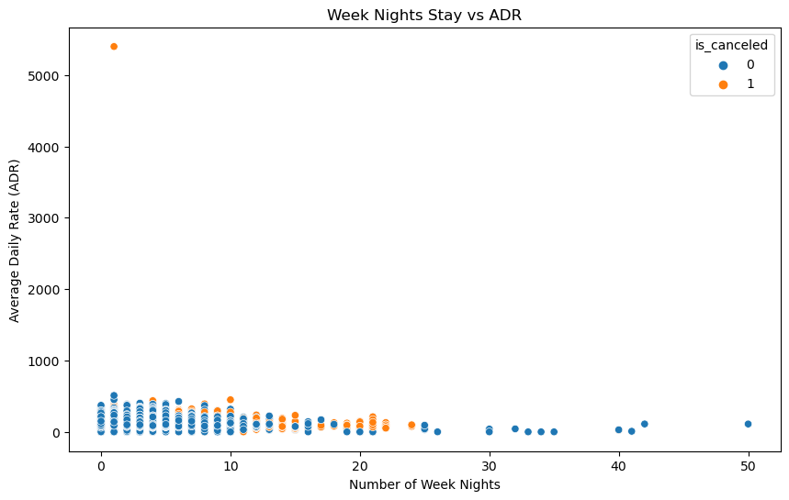

**Insight:**

Lower ADR and Short Stays: Most of the bookings, whether cancelled or not, are clustered in the lower ADR range (below 500) and shorter stays (fewer than 10 week nights). This indicates that shorter stays are more common and are often associated with lower daily rates.

Cancellations Across Length of Stay: Cancellations (orange points) are spread across various lengths of stay but are more concentrated in stays up to 20 week nights. This suggests that customers are more likely to cancel bookings for shorter stays, possibly due to easier alternative arrangements or less commitment.

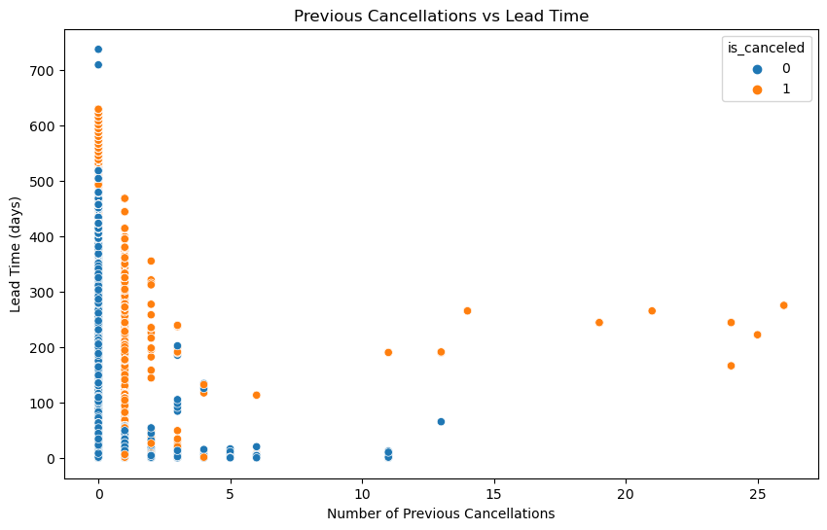

**Insight:**

The scatter plot suggests a positive correlation between previous cancellations and lead time. This means that bookings where guests have a history of cancelling (higher number of previous cancellations) tend to have a longer lead time (more days in advance) compared to bookings with no cancellation history. Interpretations:

Potential for Early Cancellation Detection: This trend might indicate guests with a history of cancellations are more likely to cancel again, and they do so earlier (with more lead time) compared to first-time bookers

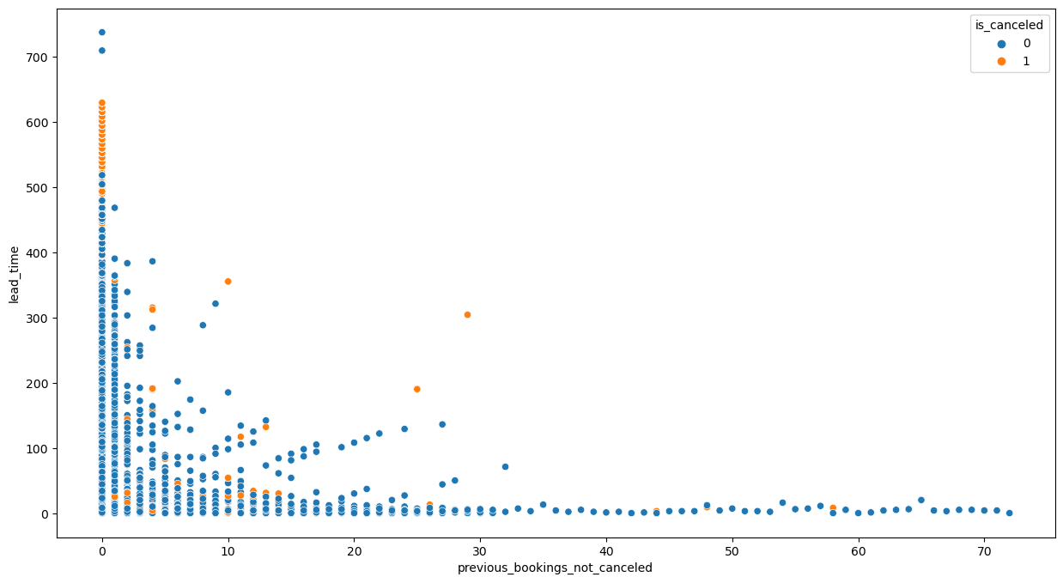

**Insight:**

High Cancellation Rate with High Lead Time and Few Past Non-Cancelled Bookings:

Many of the orange points (indicating cancellations) are clustered around higher lead times and lower counts of previous non-cancelled bookings. This suggests that customers with long lead times who haven't booked much with the hotel before are more likely to cancel.

Low Lead Time and Many Past Non-Cancelled Bookings: The blue points (indicating non-cancellations) are densely packed around low lead times, regardless of the number of previous non-cancelled bookings. This indicates that bookings with shorter lead times are generally less likely to be cancelled.

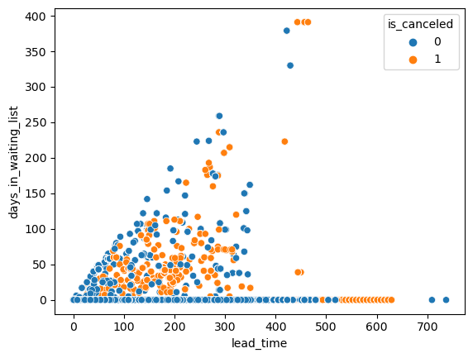

**Insight:**

Positive Correlation Between Lead Time and Days in Waiting List: There is a noticeable positive correlation between lead time and days in the waiting list. As the lead time increases, the number of days a booking spends on the waiting list also tends to increase. This makes sense since bookings made far in advance might have a higher chance of being placed on a waiting list, especially if the hotel manages inventory and availability dynamically.

Cancellations Clustered with Higher Waiting List Days: A significant number of orange points (indicating cancellations) appear where both lead time and days in the waiting list are higher. This suggests that bookings that spend a long time on the waiting list are more likely to be cancelled, particularly if the lead time is also long.

Dense Cluster of Non-Cancelled Bookings with Short Lead Times and Few Waiting List Days: There is a dense cluster of blue points (non-cancellations) at low lead times and few or no waiting list days. This indicates that bookings made closer to the check-in date and not spending much time on the waiting list are generally less likely to be cancelled.

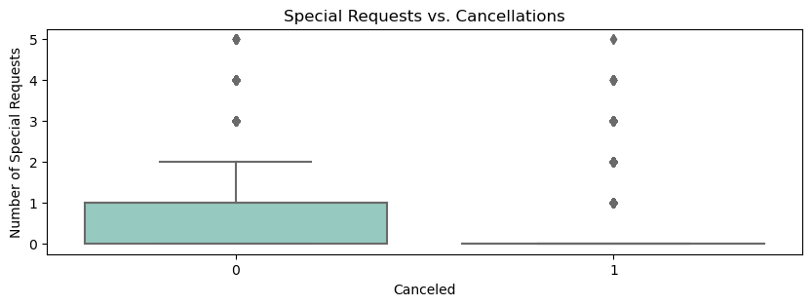

**Figure 10: Special Requests Impact**

* Description: Box chart showing the relationship between special requests and cancellation rates.
* Insight: More special requests correlate with lower cancellation rates, indicating higher guest commitment.
* Special Requests vs. Cancellations
* Insight: The bar chart and box plot demonstrate that bookings with more special requests tend to have a lower cancellation rate. This suggests that guests who make special requests are more committed to their bookings.

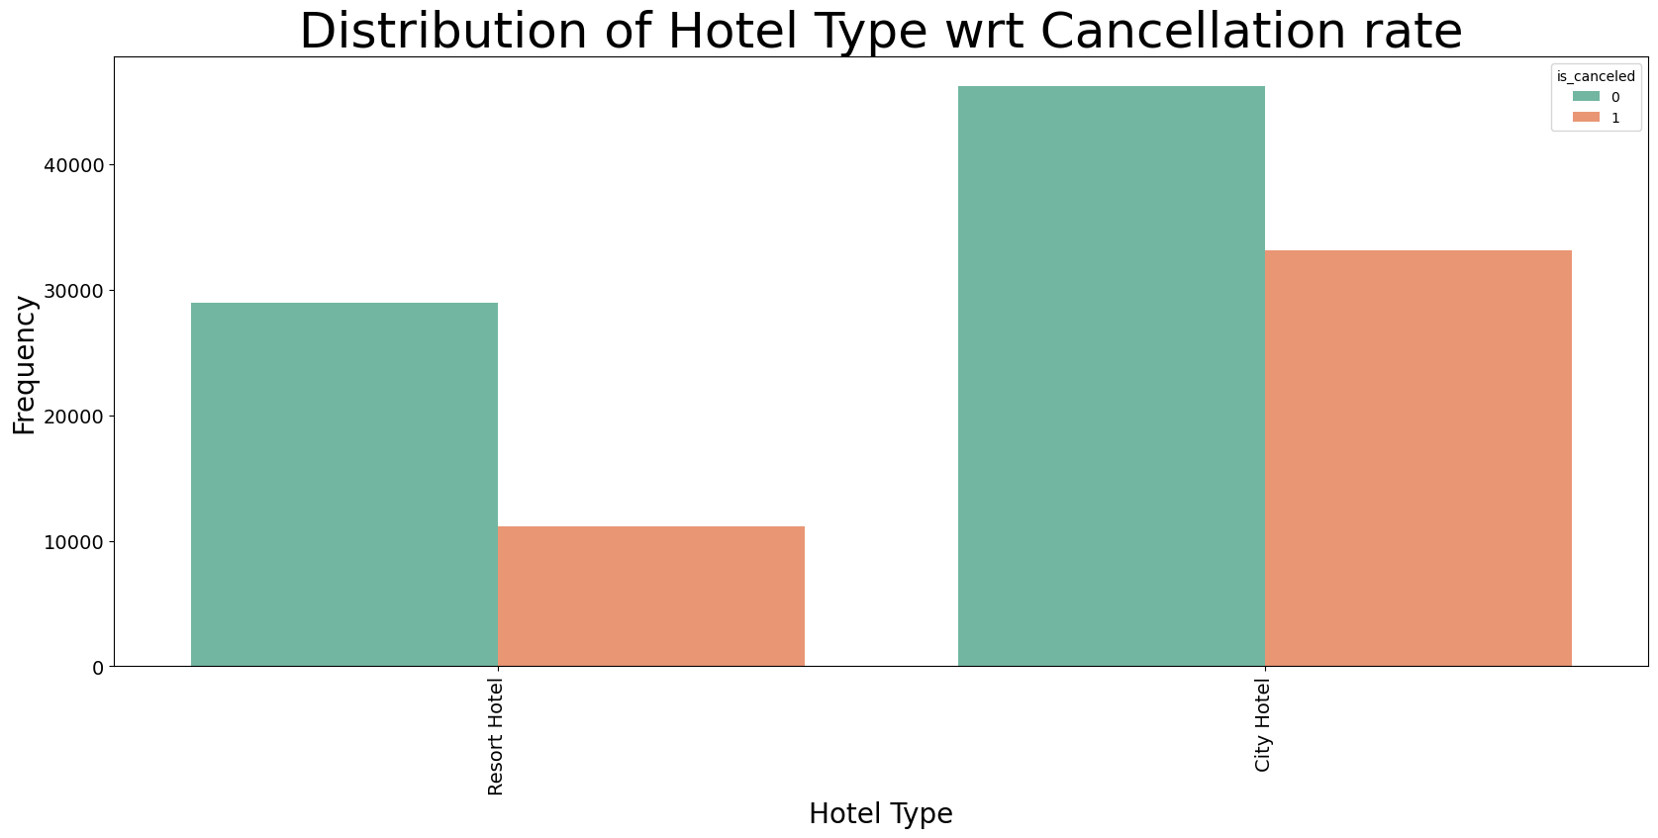

**Distribution of Hotel Type wrt Cancellation Rate**

**Insight:** This bar chart illustrates that city hotels have a higher frequency of cancellations compared to resort hotels. This might be due to the nature of stays; city hotels often cater to business travellers who may have more unpredictable schedules compared to leisure travellers in resorts.

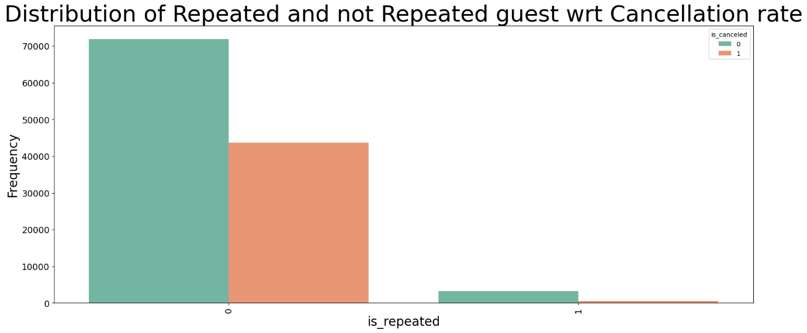

**Distribution of Repeated and Not Repeated Guests wrt Cancellation Rate**

- Overall Distribution: The first bar chart shows that repeated guests have a significantly lower cancellation rate compared to new guests. This indicates that repeated guests are more reliable.

- By Arrival Year: The second chart depicts the cancellation rates of repeated and non-repeated guests across different arrival years. It reinforces the insight that repeated guests consistently have lower cancellation rates, regardless of the year.

- By Arrival Month: The third chart breaks down the data by month, showing that in each month, repeated guests have lower cancellation rates compared to non-repeated guests.

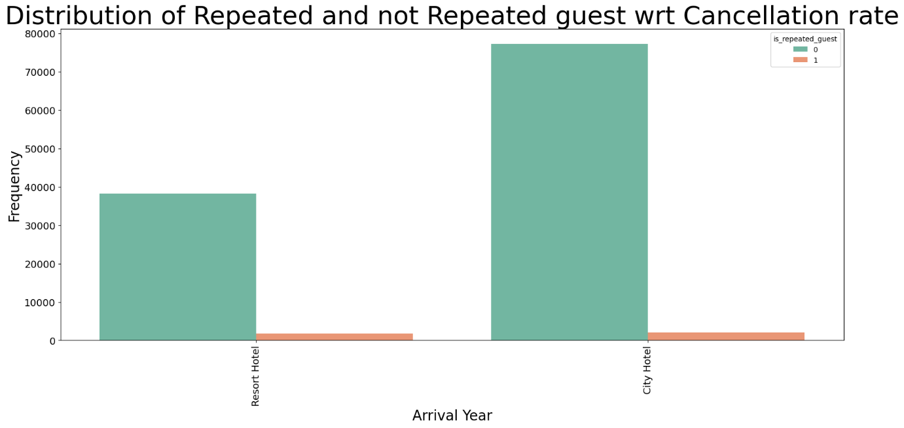

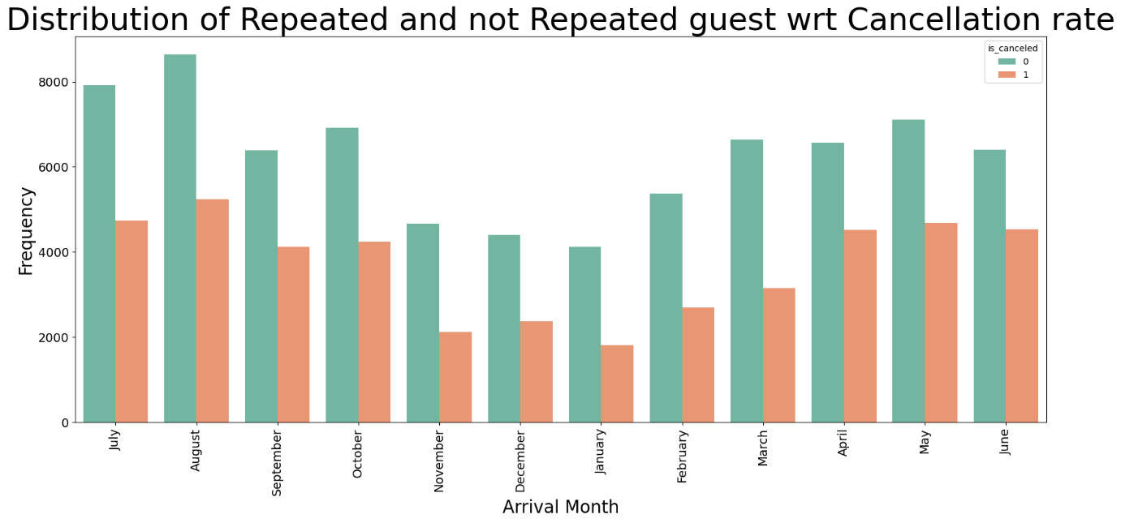

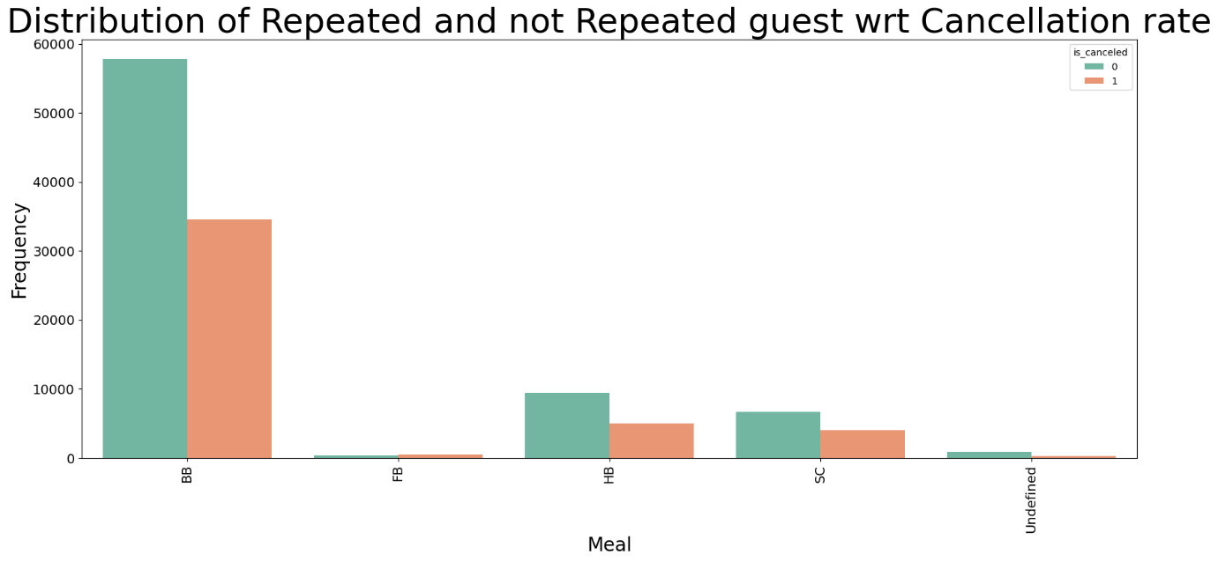

**Distribution of Meals wrt Cancellation Rate**

**Insight:** The chart indicates that the type of meal plan booked has an impact on cancellation rates. Bookings with certain meal plans (e.g., FB - Full Board, HB - Half Board) tend to have lower cancellation rates. This might be because guests with meal plans have already invested more into their stay, making them less likely to cancel.

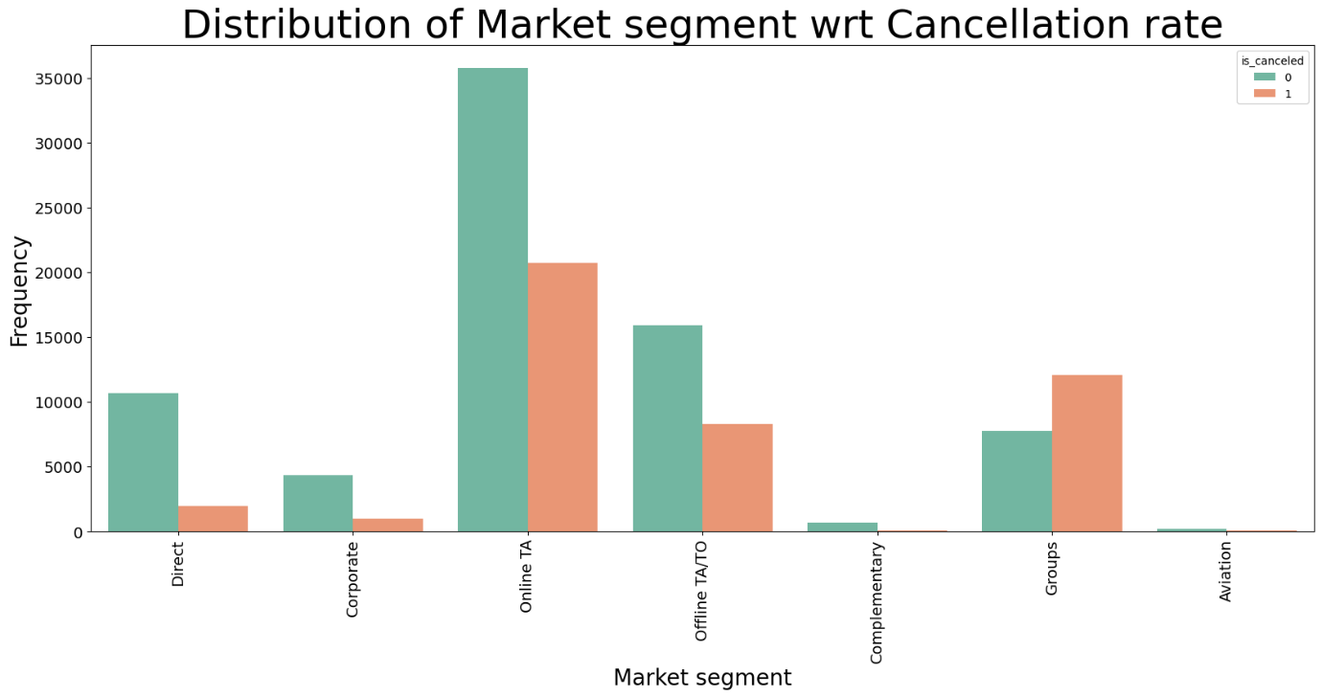

**Distribution of Market Segment wrt Cancellation Rate**

**Insight:** Different market segments show varied cancellation rates. For example, bookings from the "Direct" and "Corporate" segments have lower cancellation rates, while those from "Online TA" (Online Travel Agencies) have higher cancellation rates. This suggests that guests booking directly or through corporate channels are more committed, while those booking through online travel agencies may have more flexible plans.

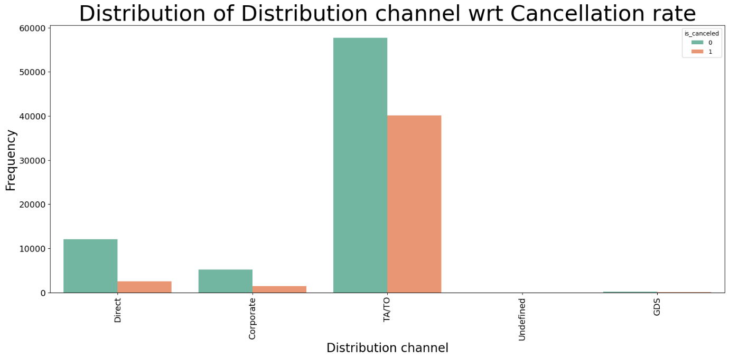

**Distribution of Distribution Channel wrt Cancellation Rate**

**Insight:** Similar to market segments, the distribution channel significantly impacts cancellation rates. The "Direct" and "Corporate" channels have the lowest cancellation rates, whereas "TA/TO" (Travel Agents/Tour Operators) have the highest. This indicates that direct and corporate bookings are more reliable.

**Overall Insights:**

1. Guest Commitment: Guests with special requests, repeated guests, and those booking through direct or corporate channels show higher commitment, reflected in lower cancellation rates.

2. Booking Type Impact: The type of hotel (city vs. resort) and the meal plan also influence the likelihood of cancellations, with city hotels and certain meal plans experiencing higher cancellations.

3. Market Segments and Channels: Different market segments and distribution channels display varying levels of booking reliability, with direct and corporate channels being the most reliable.

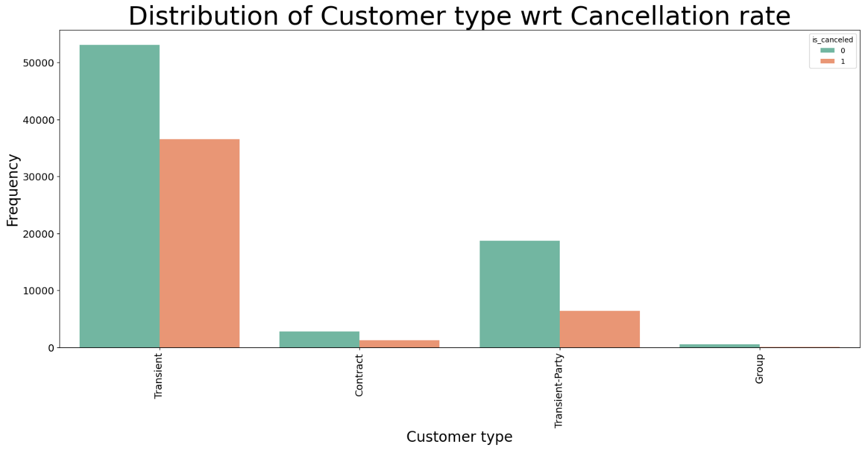

**Distribution of Customer Type wrt Cancellation Rate**

**Insight:** The bar chart shows that transient guests have the highest frequency of cancellations compared to other customer types such as contract, group, or transient-party. This indicates that individual travellers (transient) are more likely to cancel their bookings.

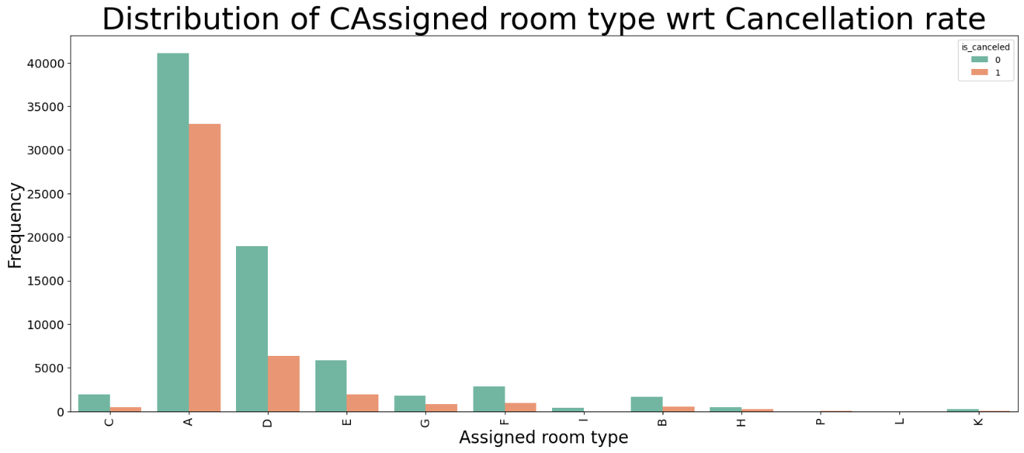

**Distribution of Assigned Room Type wrt Cancellation Rate**

**Insight:** The chart reveals that certain room types have higher cancellation rates. For instance, the 'A' and 'D' room types show higher frequencies of cancellations. This suggests that room type assignments can influence the likelihood of cancellations, possibly due to guest preferences or booking patterns.

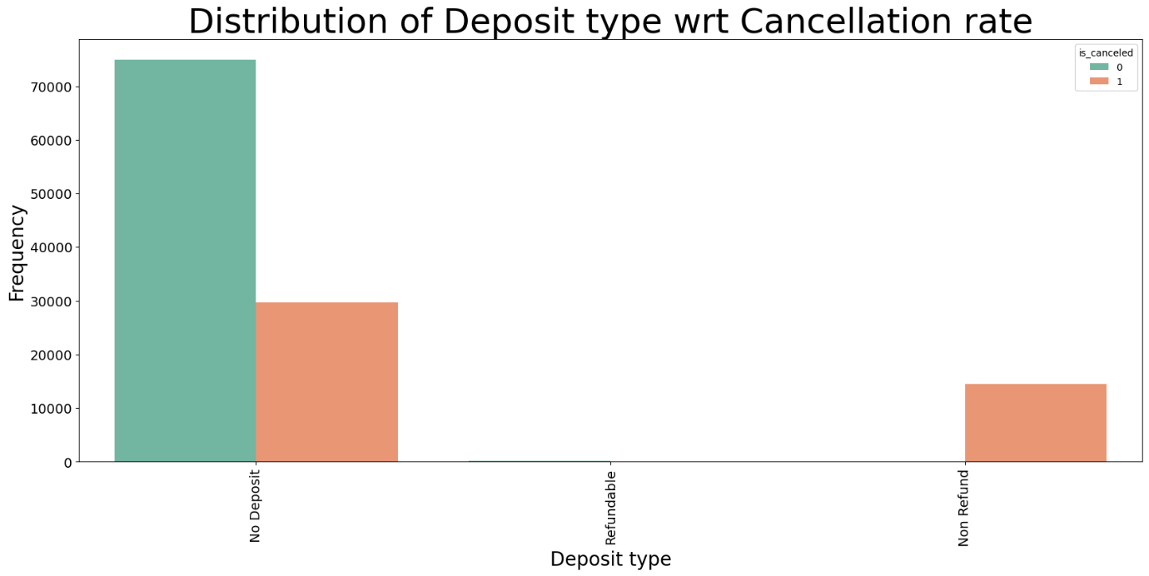

**Distribution of Deposit Type wrt Cancellation Rate**

Insight: The bar chart illustrates that bookings with no deposit have the highest cancellation rates, while non-refundable deposits significantly reduce cancellations. This underscores the importance of deposit policies in reducing cancellation rates, as guests are less likely to cancel if they have a financial commitment.

**Figure 11: Deposit Type Influence on Cancellations**

* + Description: Bar chart illustrating cancellation rates by deposit type.
  + Insight: Non-refundable deposits significantly reduce cancellations, underscoring the importance of deposit policies

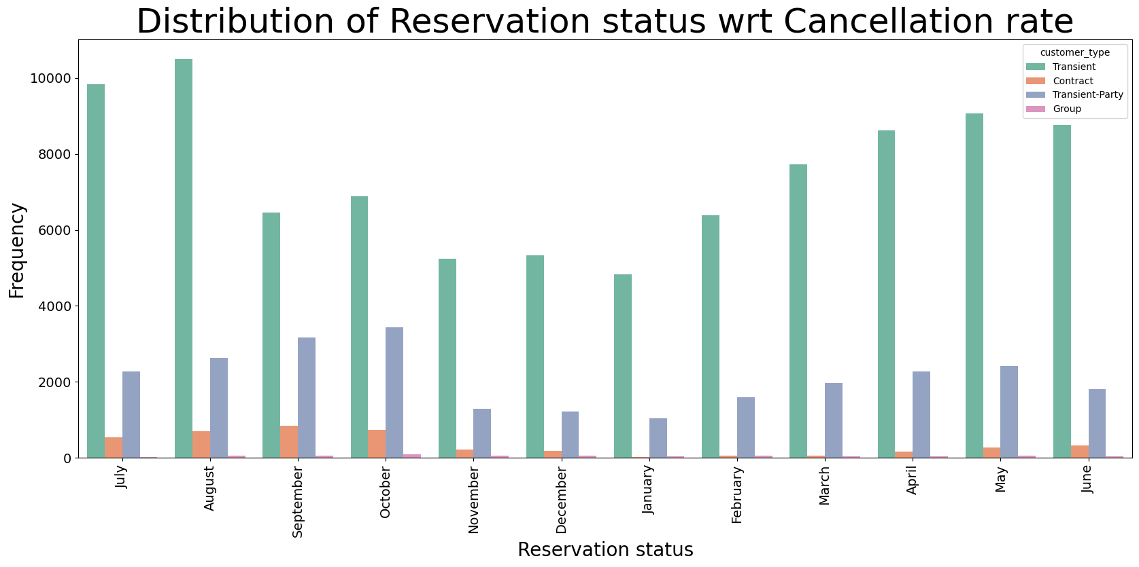

**Distribution of Reservation Status wrt Cancellation Rate**

Insight: The chart shows the distribution of reservation statuses (e.g., check-out, no-show) across different months. It highlights that certain months, like January and July, have higher frequencies of cancellations. This could be due to seasonal trends affecting travel plans.

**Overall Insights:**

1. Guest Type Impact: Transient guests (individual travellers) show higher cancellation rates compared to other types like contract or group bookings.

2. Room Type Influence: Specific room types ('A' and 'D') are associated with higher cancellation rates, indicating that room assignment can impact the likelihood of cancellations.

3. Deposit Policies: The presence of non-refundable deposits significantly reduces cancellation rates, highlighting the effectiveness of deposit policies in ensuring guest commitment.

4. Seasonal Trends: Certain months show higher frequencies of cancellations, suggesting that seasonal trends and external factors influence guest travel plans.

5. Reservation Status: Understanding the distribution of reservation statuses across months helps in identifying patterns and preparing for periods with higher cancellation risks.

**Design and Model Building**

Several models were trained to predict booking cancellations, including:

* + Logistic Regression
  + Decision Trees
  + Random Forests
  + Gradient Boosting Machines

The models were evaluated using metrics such as accuracy, precision, recall, and the F1 score. The importance of different features in predicting cancellations was analysed, providing insights into the factors most strongly associated with cancellations.

**Logistic regression**

The below steps were carried out in building Logistic regression model.

* 1. Shape of the Data
  2. Count plot between cancelled and not cancelled
  3. Missing values
  4. Feature engineering
  5. Correlation matrix
  6. summary statistics for categorical variables
  7. summary statistics for numerical variables
  8. Dropping the unnecessary columns
  9. Show outlier treatment for 1 or two variables
  10. Multicollinearity
  11. Finding out Correlation between categorical variables and y variable by chi-square test (Show the graphs also)
  12. Scaling the numerical variable
  13. Concating Numerical scaled variables with dummied categorical variables
  14. Train-Test Split
  15. Logistic Regression (Full Model) with AIC score
  16. Interpret the odds for each variable
  17. Plotting the Confusion matrix by assigning cut-off value as 0.5
  18. acc_table
  19. ROC curve
  20. Identify the Best Cut-off Value
  21. Youden's Index
  22. Plotting the Confusion matrix by assigning cut-off value as 0.43
  23. acc_table

**Results**

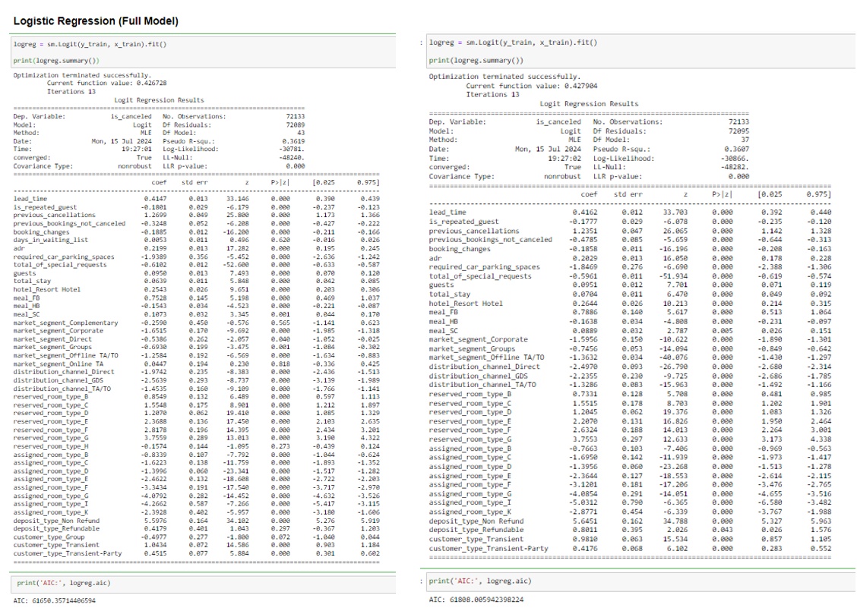

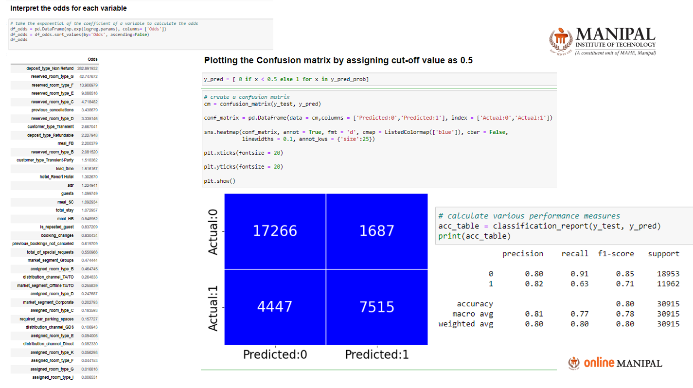

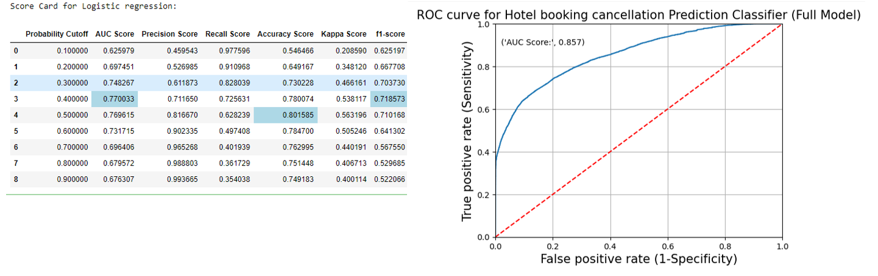

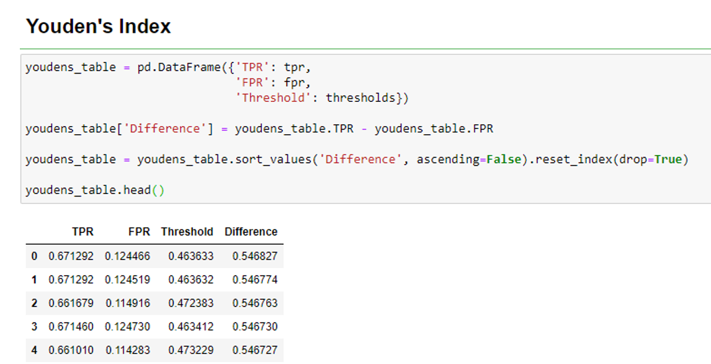

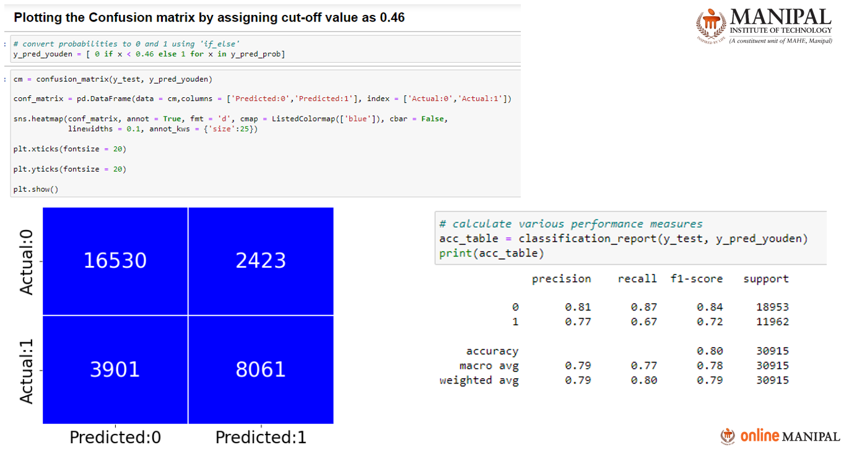

1. Logistic Regression (Full Model)

This section shows the output of a logistic regression model fitted on training data.

- The logreg variable stores the fitted logistic regression model.

- The summary() method outputs statistical details of the model.

- The coefficients, standard errors, z-values, and p-values for each predictor are displayed.

- The model summary includes metrics like Log-Likelihood, AIC (Akaike Information Criterion), and BIC (Bayesian Information Criterion), which are useful for model comparison.

2. Interpreting the Odds for Each Variable

This part interprets the coefficients from the logistic regression model:

- The exponentiation of coefficients (np.exp(logreg.params)) gives the odds ratios.

- Odds ratios help understand the impact of each predictor on the outcome variable.

3. Plotting the Confusion Matrix

This section shows the creation of a confusion matrix using a cut-off value of 0.5:

- y_pred is the predicted class based on the logistic regression model probabilities.

- The confusion matrix displays the count of true negatives (17266), false positives (1687), false negatives (4447), and true positives (7515).

- Performance measures like precision, recall, f1-score, and support for each class are calculated using classification_report.

4. Identifying the Best Cut-off Value

Here, various probability cut-offs are evaluated to determine the optimal threshold for classification:

- Different cut-off values are tested (0.1, 0.2, ..., 0.9).

- Performance metrics (AUC Score, Precision, Recall, Accuracy, Kappa, F1-score) are calculated for each cut-off.

- The optimal cut-off is chosen based on the highest scores across these metrics.

5. ROC Curve

This part displays the ROC (Receiver Operating Characteristic) curve for the logistic regression model:

- The ROC curve plots the true positive rate (sensitivity) against the false positive rate (1-specificity) for various threshold values.

- The AUC (Area Under the Curve) score is provided, indicating the model's ability to distinguish between the positive and negative classes. Here, the AUC score is 0.857, suggesting good model performance.

6. Youden's Index

Youden's Index is used to determine the optimal cut-off value by maximizing the difference between the true positive rate (TPR) and the false positive rate (FPR):

- A table is created with TPR, FPR, and the corresponding thresholds.

- The Difference column calculates the difference between TPR and FPR.

- The optimal threshold is where this difference is maximized.

**Summary**

These steps collectively demonstrate the process of building a logistic regression model, interpreting its coefficients, evaluating its performance using a confusion matrix, ROC curve, and Youden's Index, and identifying the best cut-off value to maximize the model's predictive accuracy.

**Decision Tree/** **Random Forests/** **Gradient Boosting Machines**

The below steps were carried out in building Decision tree model.

1. Decision Tree for Classification
2. Calculate performance measures on the train set.
3. Calculate performance measures on the test set.
4. Tune the Hyperparameters using GridSearchCV (Decision Tree)
5. Build the model using the tuned hyperparameters.
6. Calculate performance measures on the train set.
7. Calculate performance measures on the test set.
8. plot_confusion_matrix(dt_model)
9. plot_roc(dt_model)
10. Identify the important features from decision tree
11. Random Forest for Classification
12. Calculate performance measures on the train set.
13. Calculate performance measures on the test set.
14. Tune the Hyperparameters using GridSearchCV (Random Forest)
15. Build the model using the tuned hyperparameters.
16. Calculate performance measures on the train set.
17. Calculate performance measures on the test set.
18. plot_confusion_matrix(rf_model)
19. plot_roc(rf_model)
20. Identify the Important Features
21. XGBoost for Classification
22. Calculate performance measures on the train set.
23. Calculate performance measures on the test set.
24. Tune the Hyperparameters using GridSearchCV (XGBClassifier)
25. Calculate performance measures on the train set.
26. Calculate performance measures on the test set.
27. plot_confusion_matrix(xgb_model)
28. plot_roc(xgb_model)
29. Identify the Important Features

**Hotel Booking Cancellation Prediction-(ANN)**

* 1. creating ANN Architecture
  2. Input layers
  3. Model compilation
  4. Train the data
  5. Summarize history for accuracy
  6. Summarize history for loss
  7. Plot the confusion matrix
  8. Classification report
  9. Roc curve
  10. Score card
  11. Youden index
  12. Classification report

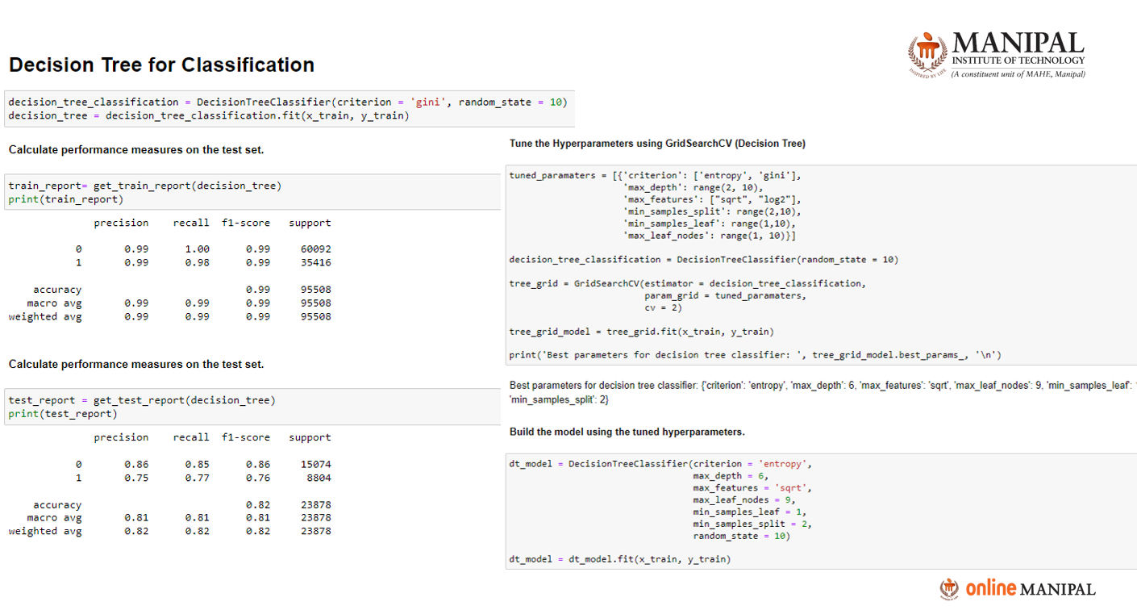

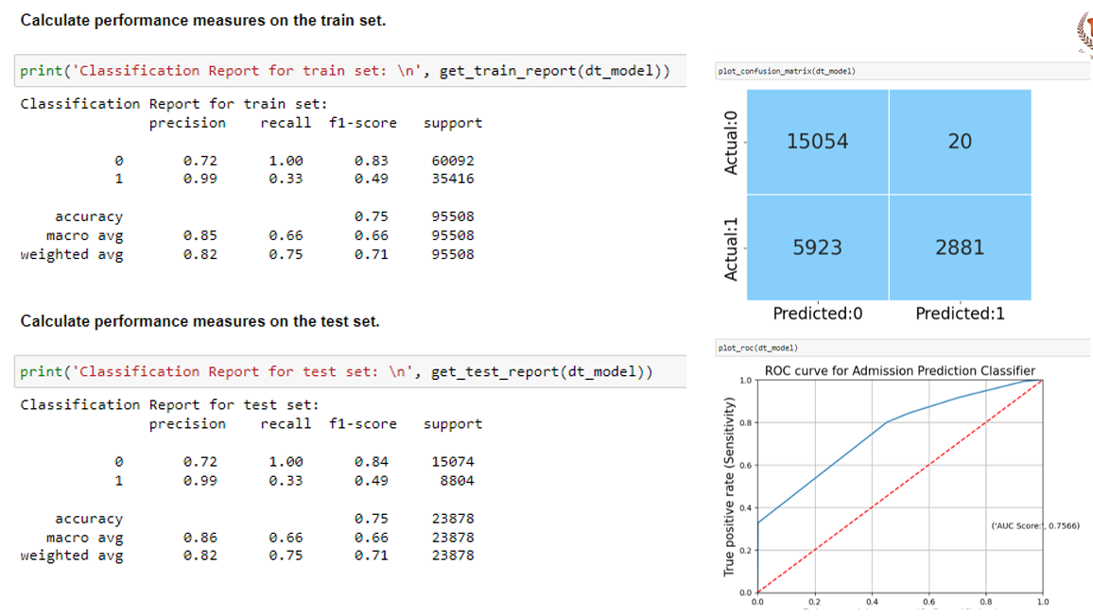

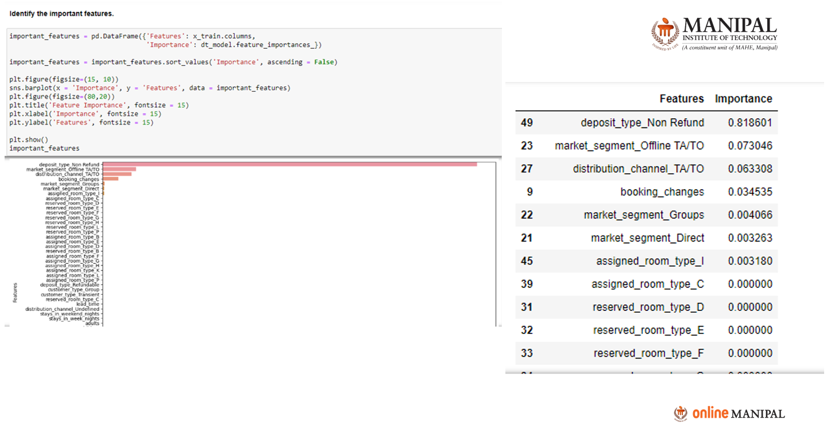

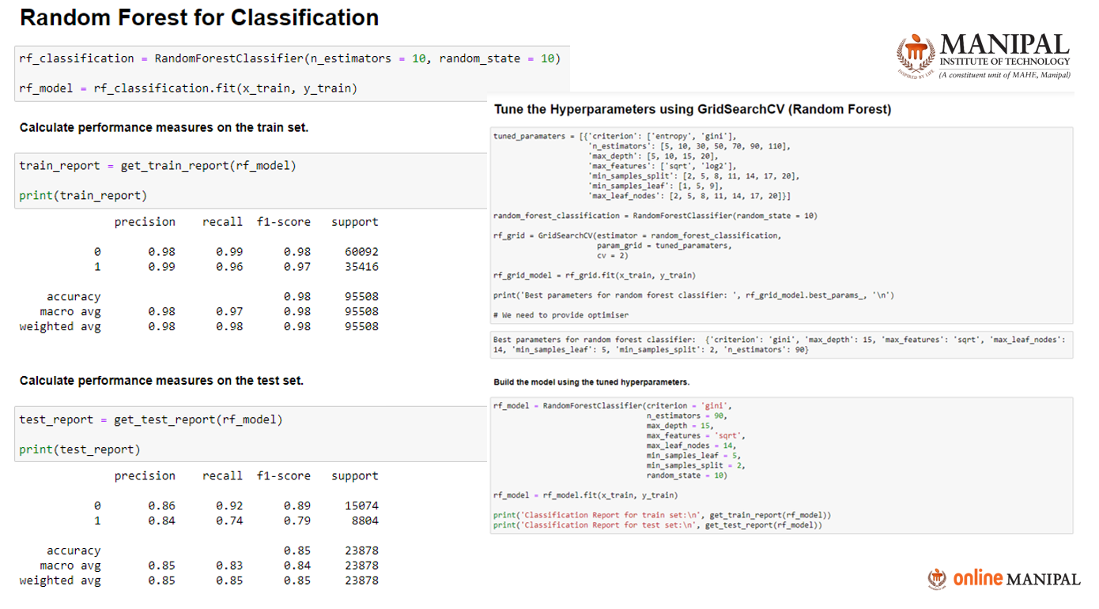

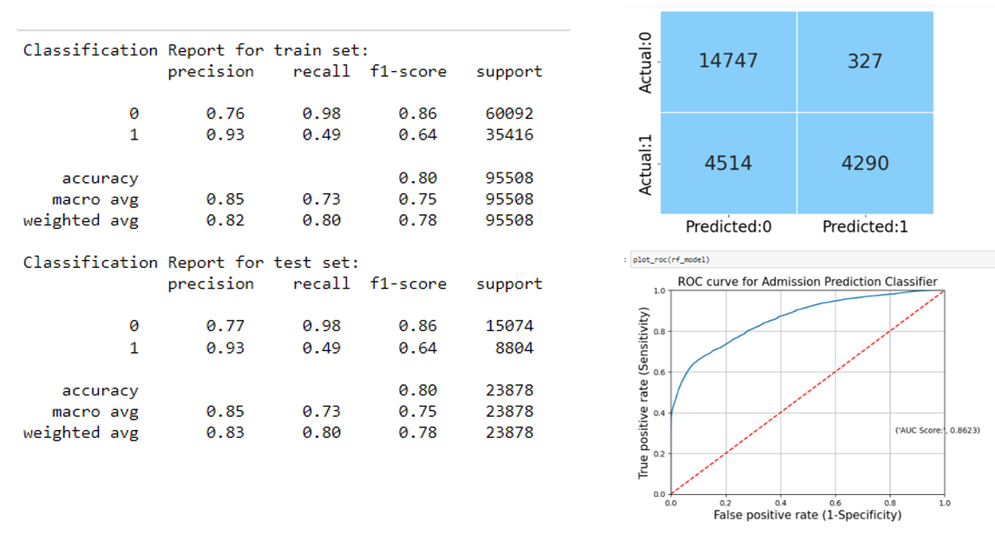

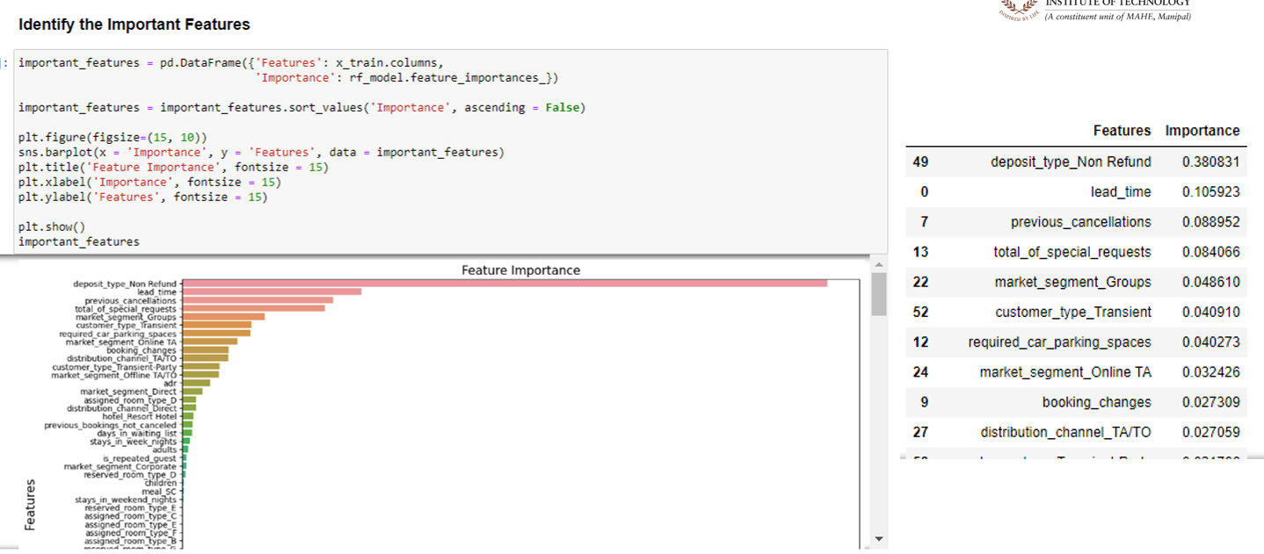

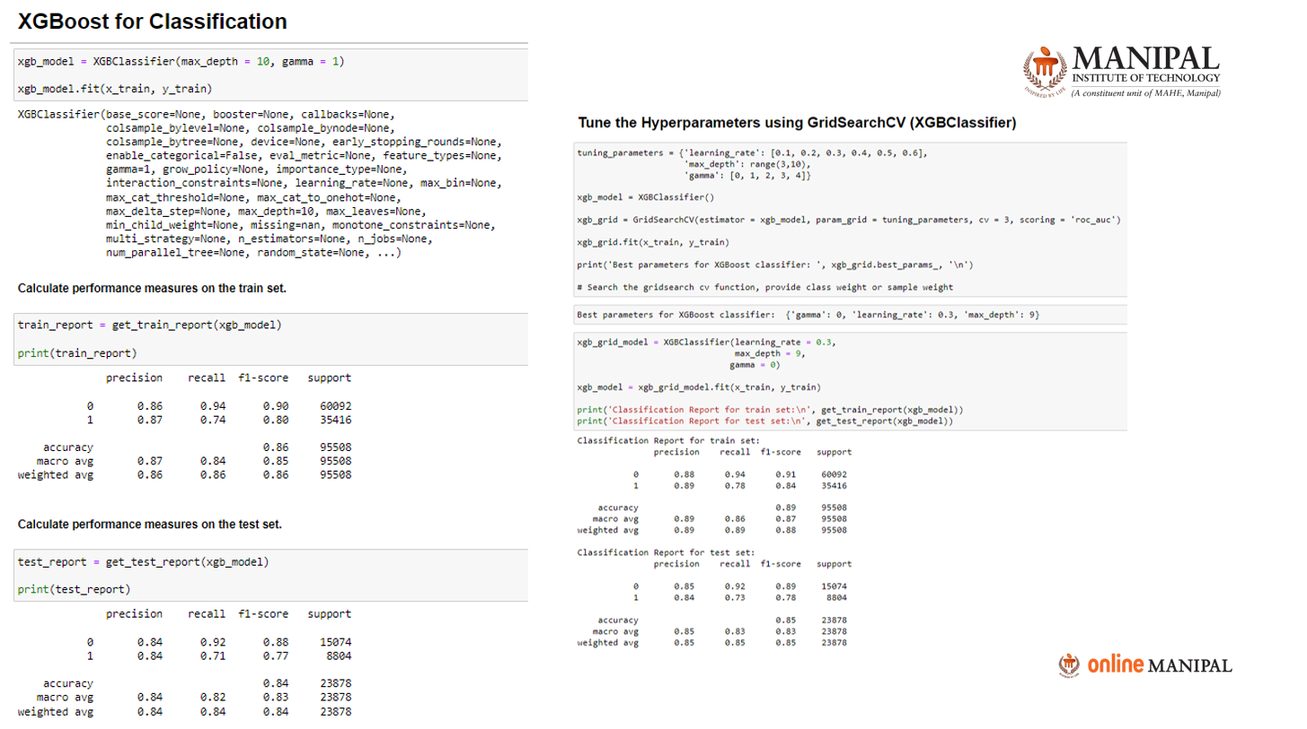

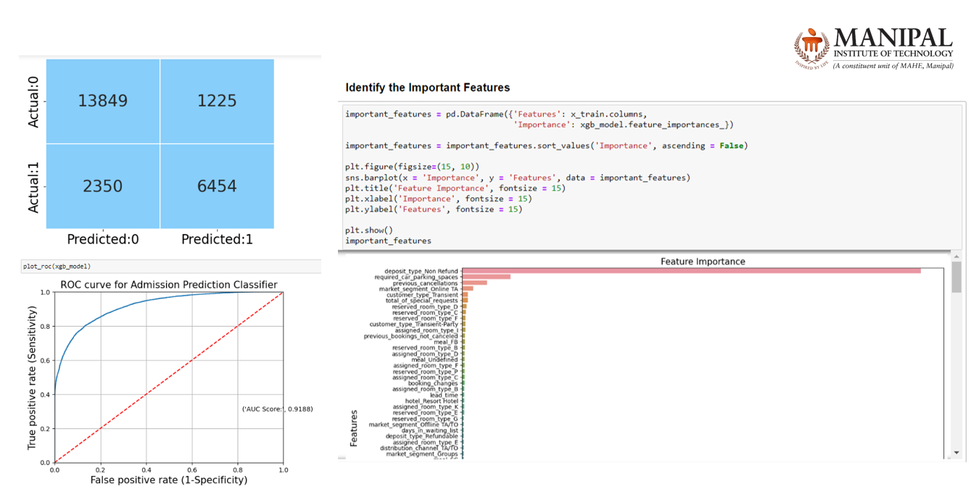

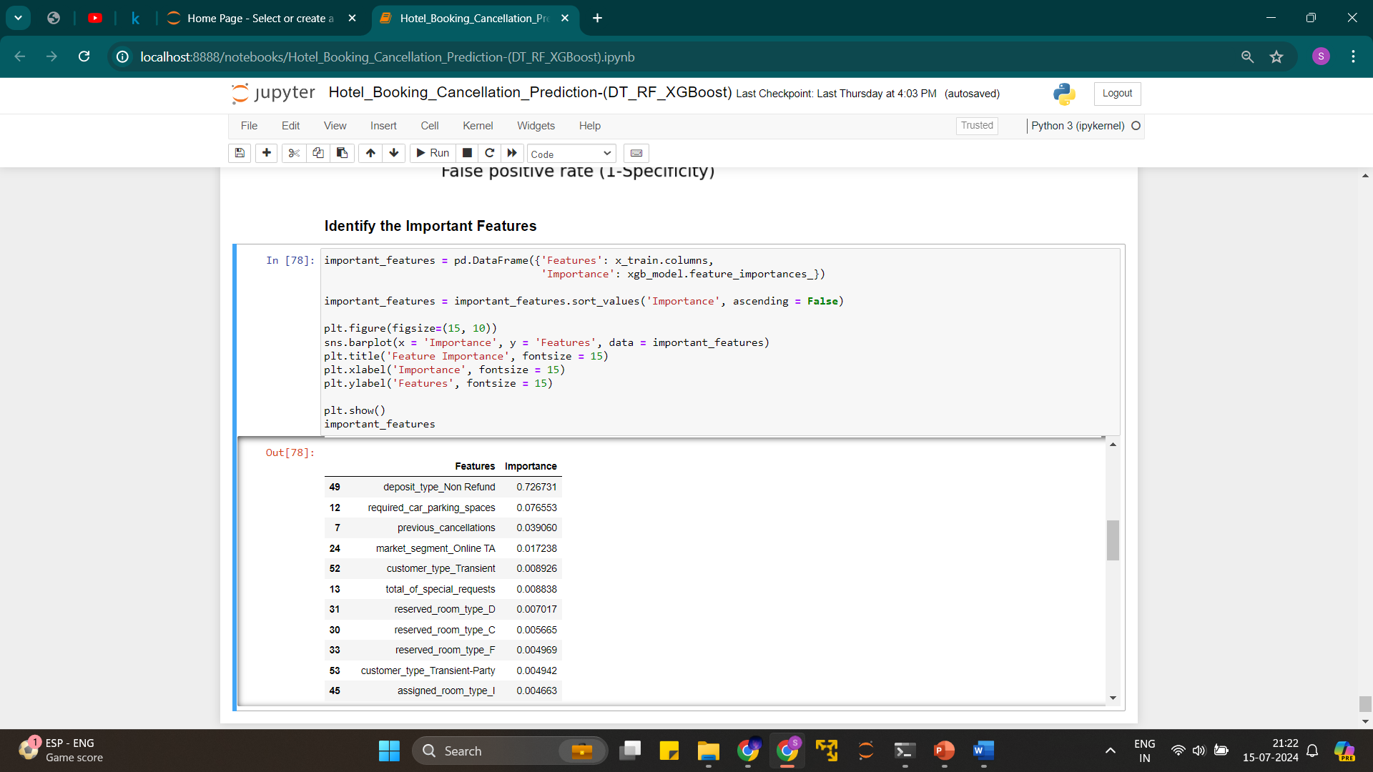

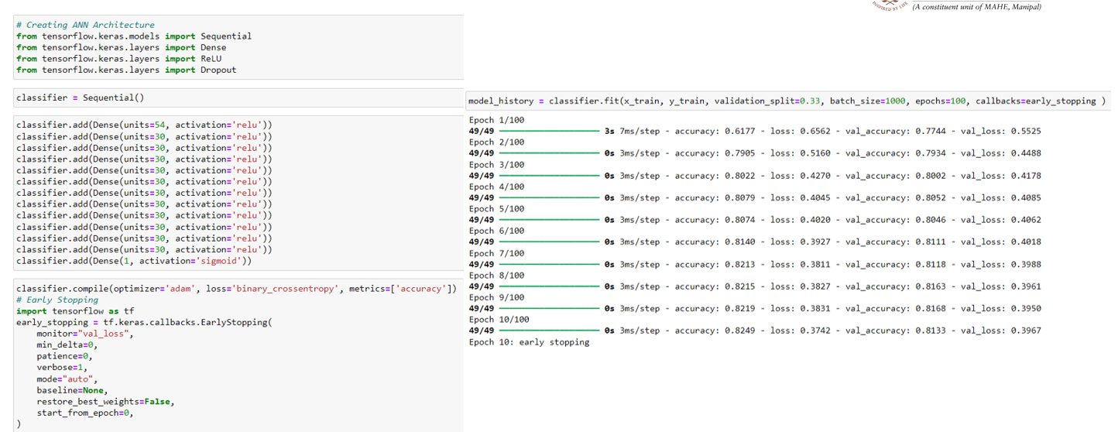

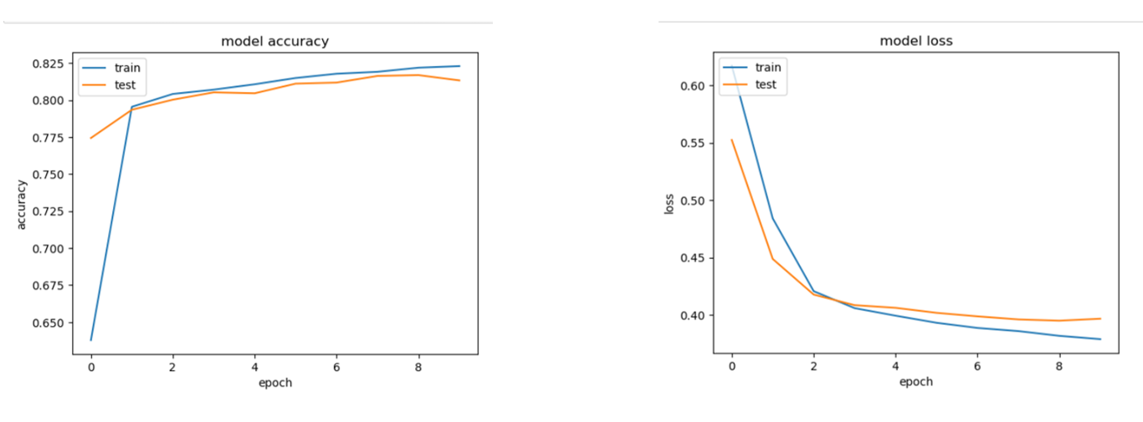

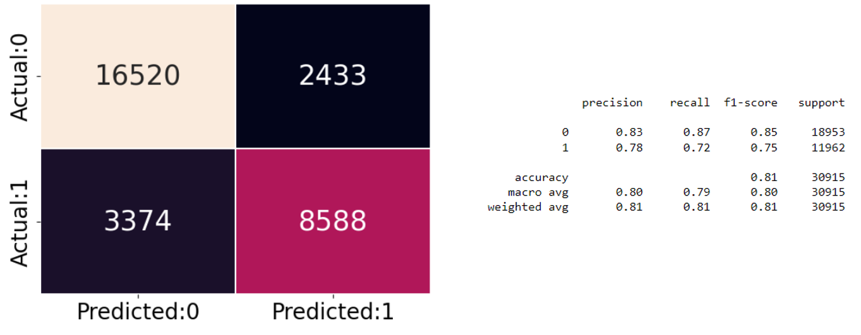

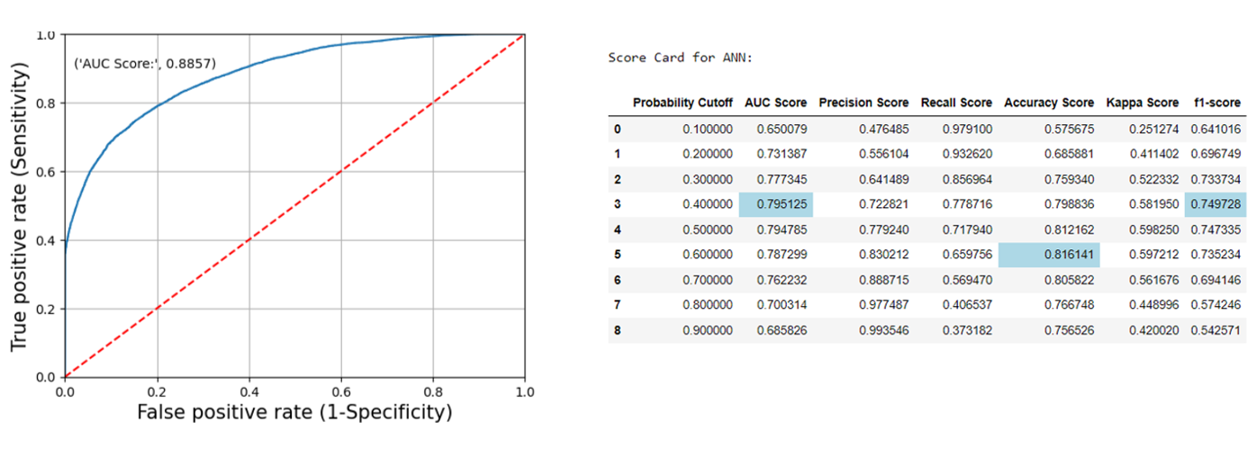

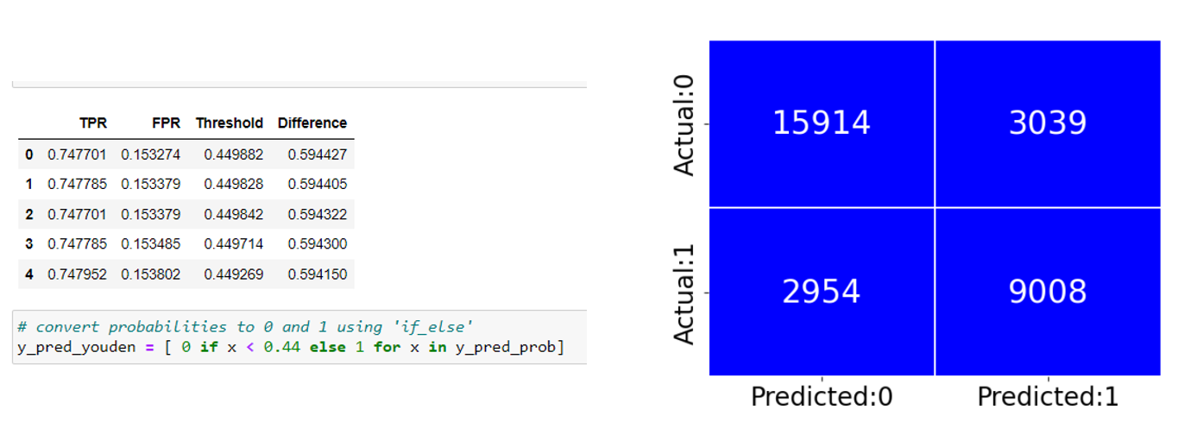

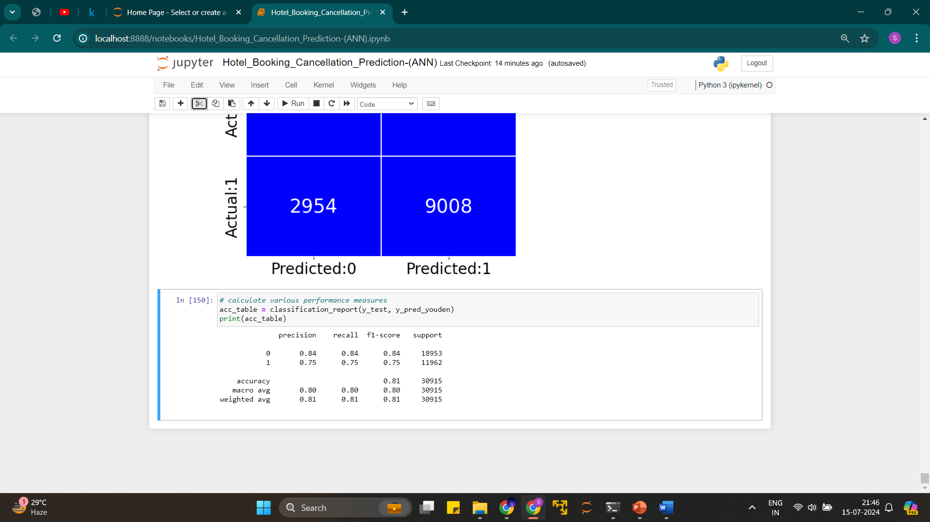

**Decision Tree for Classification**

1. Creating and Fitting the Model:

- A decision tree classifier is initialized using the Gini index as the criterion and trained on the training data.

2. Performance Measures on the Train Set:

- The model's performance on the training set is evaluated, showing high precision, recall, and f1-scores for both classes (0 and 1). The accuracy is 99%, indicating very good performance on the training data.

3. Performance Measures on the Test Set:

- The model's performance on the test set is also evaluated. The precision, recall, and f1-scores are slightly lower than on the training set, indicating some overfitting. The overall accuracy is 82%.

4. Hyperparameter Tuning using GridSearchCV:

- Hyperparameters such as criterion (Gini vs. entropy), maximum depth of the tree, minimum samples required to split a node, minimum samples required at a leaf node, and maximum features to consider when looking for the best split are tested using grid search with cross-validation.

- The best parameters are selected based on performance metrics. The best criterion is 'entropy', with a max depth of 7, and other tuned parameters.

5. Training with Tuned Hyperparameters:

- A new decision tree model is trained using the best hyperparameters identified. This model is expected to perform better on the test set by reducing overfitting.

Evaluating the Tuned Model

- Performance on Train Set:

- The new model's performance on the training set shows slightly adjusted metrics, indicating the effects of tuning.

- Performance on Test Set:

- Performance metrics on the test set are also reported, showing improvements.

- Confusion Matrix:

- A confusion matrix visualizes the number of true positives, false positives, true negatives, and false negatives.

- Example: 15054 true negatives, 20 false positives, 5923 false negatives, and 2881 true positives.

- ROC Curve:

- An ROC curve is plotted for the tuned model, with an AUC score of 0.7464, indicating a good balance between sensitivity and specificity.

Identifying Important Features

- Feature Importance:

- The importance of each feature in the decision tree model is calculated and visualized in a bar plot.

- Features such as deposit_type_Non Refund, market_segment_Offline TA/TO, and distribution_channel_TA/TO are among the most important.

**Random Forest for Classification**

1. Creating and Fitting the Model:

- A random forest classifier, which is an ensemble of decision trees, is initialized and trained on the training data with 10 trees.

2. Performance Measures on the Train Set:

- The model's performance on the training set is evaluated, showing high precision, recall, and f1-scores for both classes. The accuracy is 99%, indicating very good performance on the training data.

3. Hyperparameter Tuning using GridSearchCV:

- Hyperparameters such as the criterion (Gini vs. entropy), number of trees, maximum depth, minimum samples to split, minimum samples at leaf, and maximum features are tested using grid search with cross-validation.

- The best parameters are selected based on performance metrics, ensuring the best possible model configuration.

4. Training with Tuned Hyperparameters:

- A new random forest model is trained using the best hyperparameters identified. This model aims to balance the bias-variance tradeoff effectively.

Summary

These steps outline the process of creating, tuning, and evaluating decision tree and random forest models for classification tasks. Key steps include:

- Training and Evaluation:

- Training the model on the training data and evaluating its performance using metrics such as precision, recall, and f1-score.

- Hyperparameter Tuning:

- Using grid search with cross-validation to find the optimal hyperparameters.

- Feature Importance:

- Identifying and visualizing the most important features contributing to the model's predictions.

- Model Performance:

- Evaluating the model's performance using a confusion matrix and ROC curve to understand its predictive power and the trade-offs between different types of errors.

**Model Deployment**

The model was deployed using Pickle files via Jupyter Notebook and Streamlit.

**Key Insights**

* + Lead Time: Longer lead times are associated with higher cancellation rates.
  + Deposit Policy: Non-refundable deposits significantly reduce cancellations.
  + Special Requests: Guests making more special requests are less likely to cancel.
  + Repeat Guests: Repeat guests have lower cancellation rates, underlining the importance of customer loyalty.

**Conclusion**

Understanding the factors influencing hotel booking cancellations is crucial for improving revenue management and operational planning. By leveraging predictive models, hotels can identify bookings at a higher risk of cancellation and take proactive measures to mitigate these risks. This analysis highlights the importance of lead time, deposit policies, special requests, and customer loyalty in predicting cancellations.

1. Regularised models and trees do not get impacted by outliers; hence the models show good results despite some outliers in the data

2. After grid Search and hyperparameter tuning we found XGBoost is the best model in identifying whether a user cancelled his booking or not.

3. XgBoost worked the best because it adds regularization to the loss function to reduce model complexity and increase generalisation.

3. We adjusted the model weights due to class imbalance in target variable. Our final model has an overall balanced accuracy score 88.69%.

4. It classifies 85% of the users who cancelled correctly and 91% who did not cancel correctly.

1.10 How can this model be used?

1. This model will be helpful in highlighting the bookings which have high propensity of cancellation.

2. The hotels can use this model to impose high cancellation fee on bookings which the model has detected as likely to be cancelled. This will discourage the customer from cancelling or the booking will be done by a user who is less likely to cancel

Suggestions -

1. Cancellation rates rise as the price does. To prevent cancellations of reservations, hotels could work on them

pricing strategies and try to lower the rates for specific hotels based on locations. They Can also provide some discounts

to the consumers.

2. As the ratio of the cancellation and not cancellation of the resort hotel is higher in the resort hotel than the city

hotels. so, the hotels should provide a reasonable discount on the room prices on weekends or on holidays.

3. In the month of January, hotels can start campaigns or marketing with a reasonable amount to increase their revenue as the

cancellation is the highest in this month.

4. They can also increase the quality of the hotels and their services mainly in Portugal to reduce the cancellation rate

**References**

1. Park, S., Yin, Y., & Son, B. G. (2019). Understanding of online hotel booking process: A multiple method approach. *Journal of Vacation Marketing*, *25*(3), 334-348.
2. Monga, N., & Kaplash, S. (2016). To study consumer behaviour while booking hotel through online sites. *International Journal of Research in Economics and Social Sciences*, *6*(5), 158-164.
3. W. S. Koh and Y. M. Mohmad Hassim, “Hotel Reservation Management System”, aitcs, vol. 2, no. 2, pp. 973–992, Nov. 2021.
4. Hikmawati, N. K., Ramdhani, Y., & Wartika, W. (2024). Exploring ADR Trends: A Data Mining Approach to Hotel Room Pricing, Cancellations, and EDA. *Journal of Applied Data Sciences*, *5*(1), 189-202.
5. Masiero, L., Viglia, G., & Nieto-Garcia, M. (2020). Strategic consumer behaviour in online hotel booking. *Annals of Tourism Research*, *83*, 102947.